Tips for Planning Actions

There are times when you'll be preparing a one-off action, perhaps as your contribution to someone else's campaign, or as a stand alone event in itself. Other times your action will be part of your wider campaign strategy with each and every action being a step towards your overall campaign aims. This briefing gives an introduction to the steps you can take to make your action a success. See our 'Strategy' briefing for more on planning campaigns.

An action planning flowchart - “The 6 Ws”

Ask yourselves the following 6 questions when you're planning any action. They form a framework that will help you ensure that the action you plan will deliver the results you're looking for:
WHYare you planning this action?
What is your aim? What are you trying to achieve? How does this action fit into your wider campaign?
WHERE will the action happen?
Is there a venue that will maximise it's impact? This might be somewhere symbolic, or somewhere where your action will get the most attention. Maybe the location's dictated to you – if you want to pull up a genetically manipulated crop, you have to go to where it's growing, for example.

WHAT is the MESSAGE of the action?
Keep it simple and clear and relevant to your target(see below)

WHEN will your message be heard the loudest?
Is there a time that maximises the impact of your action? Do you want your action to coincide with a meeting or conference, with the visit of a politician or dignitary. Should it coincide with a public announcement or press release, with the start of a war or other act of injustice? Maybe you want it to happen at a time when the media will be available (no point holding your press stunt in the middle of the night) or when the are will be full of commuters or shoppers?

WHO are you aiming the action at?
Who do you want to hear your message? Who is your target?
Some actions might be aimed at the staff of a corporation or government office. Other might be aimed directly at members of the public. Still others might be aimed at the media. The way you phrase and communicate your message will vary depending on your chosen target

HOW will you get the message out?
What form will the action take? What tactic(s) will you use?
Do you want to do a press stunt, or take direct action? Maybe you just want to raise awareness amongst the public and can use a street stall or leafleting to achieve that?

Don't forget that your choice of action may be influenced by other, important factors:
Glossary
aim – what you want to have achieved at the end of the action. If the action is part of a bigger campaign, this will be one step towards your overall campaign aim

target – the person or people you are aiming your action at

tactics – your chosen method for taking action – media stunt? street leafleting? office occupation? sit down road blockade? banner hanging?

Resources:
What skills do you have within your group? How much money do you have? How much time and energy can you put into the action? Have you got enough people to make it happen? If you lack any of these, can you realistically get them in time?

Democracy:
Is everyone involved in the decision making process? Is this an action that everyone will enjoy taking part in or supporting? Does it need specialist skills that prevent most people taking part? How can you include as many people as possible in the action?

Many action groups suffer from small numbers in the group. Planning inclusive actions can attract people and encourage them to stay! You might find it useful to read our briefing on Consensus Decision Making.

Getting your message across

Keep the message of you action simple. That's not always easy when you're dealing with complex environmental or social issues, but a simple message will make your action more effective. You might have to reduce the number of arguments you make through your action in order to ensure you get one or two across clearly. Communicate the same message in as many different ways as you can – for example both verbally and visually. A few clear, simple banners and placards can make all the difference.

Be careful to make your action match your message. If you're wanting to communicate direct to the public, and win them over to your side of a debate, an action that alienates them, scares them, or inconveniences them might not be the best option. People will remember how you communicated with them more strongly than the message that you were trying to communicate. If they leave the action site angry with you, that's what they'll remember, and you'll have lost their support. If they leave impressed with your conviction, laughing at your humour, or angry with the people you are campaigning against, great!

Preparing Your Action

Once you've answered the 6 “W” questions and decided your aim, target and tactics, you need to get on and prepare the action. If you're planning on taking direct action it might help to read our briefing Preparing for Action.

Participation and skillsharing
This is a good point to think again about participation in your group. Can everyone get involved in preparation for the action? The more involved people feel the more committed to the action and to the group they will be. Planning and preparing an action can be an ideal opportunity for some informal skillsharing within your group. Why not match up those people with certain skills with those who'd like to learn them?

Action groups that let the same 'core' people take on all the work all the time regularly run into problems. If a few people do all the work, they are stopping others developing their skills, interests and talents. They're also creating a situation in which people get used to relying on them and passing the buck, so when they really could do with a hand, no-one's there to give it. Encourage everyone to take on responsibility - share skills and talents, even if at first it seems like it would be quicker to do it yourself. It will pay off in the longer term.

“What if...”
No action ever goes 100% according to plan, so it's worth sitting down and thinking through a few possible “what if” scenarios. What if the van carrying all the props gets stuck in traffic? What if only 10 people show up? What if 100 people show up? What if the media don't come? The more of this kind of thinking you can do in advance the more prepared you'll be for the actual event.

Roles and Tasks for Action Planning
Here's just a few of the tasks that might need doing in advance, for your action to happen:

- Equipment and props - what materials do you need and where will you get them? What can you get for free from skips, what do you need to buy, and what can you make?
- Transport – you might need a vehicle to gather together your equipment, and transfer it to the action site. You might also need to get people to the action. Who can drive?
- Reconnaissance – Scouting out your action site is common sense. If you want to occupy the foyer of a corporate headquarters it's best not to see it for the first time on the day of the action! Take a wander round at the time of day your planning on doing the action. Take photos and draw maps if you can do so without attracting undue attention. Remember, whoever does the 'recce' needs to be able to pass all the information on to others later!
- Research - find some facts and figures that support your action – the more reputable the better. You can use them in news releases and interviews, and on banners and leaflets.
- Propaganda
- Leaflet - you'll probably need to find an existing one or write one from scratch. Who are you aiming it at? You might write different text for a member of the public than you would for an employee of the company you’re targeting. Remember to keep the text simple and relevant. Reference facts to their source wherever possible, and let people know where they can find more information if they want it. Don't forget a contact phone number or email address for your group, if you're comfortable with people getting in touch. Graphics can really help make your leaflet more interesting to read. Do you have a group artist or photographer? Can you find graphics on the internet?
- Banners and Placards – very simple tools for communicating your message. If you don't have any free hands on the action, make T-shirts instead and wear your message. Banners can also serve other purposes such as blocking roads.
- Media - you might be able to increase the impact of your action by using the media. Send news releases, make sure there's a good photo opportunity, maybe appoint a media spokesperson. With the right visual image you can almost guarantee a photo in your local newspaper. Be creative but also be careful. Not all journalists will share your ideals! Read our briefing on Using the Media for more ideas. Don't forget to use the alternative media!
- Publicity – If your action is open to others, make sure people who might be interested know about the action, and when and where to meet.

- Briefing – You might need to ensure that people on the action know what it's about - you could arrange a speaker meeting the week before, send a briefing by email, or meet in a pub or cafe beforehand to talk or read through it. Do people need to see photos or a map, or understand their legal rights in advance?
- Legal Rights – some actions bring us into contact with the authorities so it can help to know your legal rights in advance. Someone might need to do some research and present their findings to the group. You might even want to consult a solicitor. See www.activistslegalproject.org.uk for free legal advice for activists.
- Training and Skillsharing – will the action require any specific skills or experience? Do you have them in the group or do you need to find them? For example you might want to do a blockade, or know how to make quick decisions on an action. See our website for sources of support www.seedsforchange.org.uk
- Venues – do you need a particular venue for your action, or somewhere for people to sleep the night before? Maybe you need somewhere to store people's belongings during the action or somewhere to park vehicles?

Debriefing the action
When it's all over, sit down and have a debrief. Ask yourselves what went well and what could have gone better. Celebrate your successes and learn from your mistakes. It can be easy to sweep problems under the carpet, only for them to re-emerge next action, so don't be afraid to deal with them. Build in some social time for people to unwind and tell their personal action stories. If you want to keep working together in future and planning ever more successful actions, debriefs are essential! Your debrief can also be the springboard for your next action as new ideas emerge from the experience of the action you've just done.

For more briefings on grassroots activism, and to find out about training workshops look at our website:

www.seedsforchange.org.uk

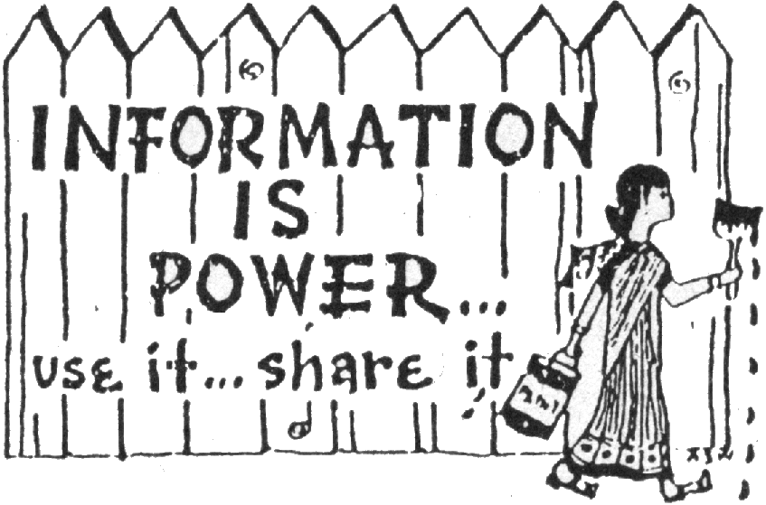
Seeds for Change Lancaster
96 Church Street, Lancaster, LA1 1TD
lancaster@seedsforchange.org.uk
0845 330 7583

Seeds for Change Oxford
16b Cherwell Street, Oxford, OX4 1BG
oxford@seedsforchange.org.uk
0845 458 4776

A non profit network of social change trainers
This briefing is @nticopyright - copy & distribute freely!

