Dynamic and Inspiring Campaign Groups

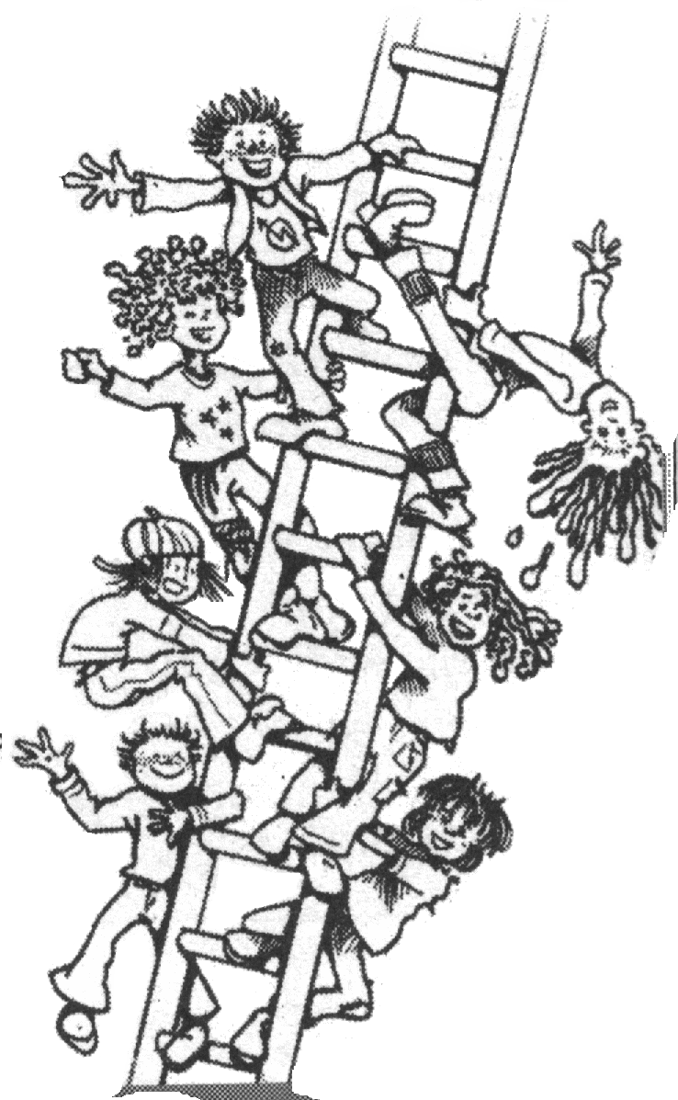
For some of us setting up and working in an exciting, and active campaign group is as simple as inviting a few mates to get together and sorting out a venue for the first meeting. But those are the lucky few. For most of us a really good campaign group is the product of a lot of thought and a fair bit of work. Don't let that put you off though, because a good group can be truly amazing.

Whether you're involved in setting up a campaign group from scratch, or trying to keep an existing group try to make participation, empowerment and long-term sustainability central to your group.

Working in Groups

Meeting People's Needs: A golden rule of working in groups is to ask ourselves what people want from the group and, where reasonable, make sure the group gives it to them. Don't be fooled into thinking that people will just want to get involved in a particular campaign. They'll almost always also want to do some of the following, however unreasonable they might sound, even if they're not aware of it at the time. And most importantly, don't be fooled into thinking this doesn't include you:

- meet new people and make some friends
- feel included and involved
- find a substitute family, community, or personal identity
- show off their skills and expertise
- feel valued, or even indispensable
- have a good rant about the state of the world
- get laid
- feel that they've made a difference
- feel 'alternative'
- climb onto their high horse or the moral high ground
- learn something new
........and much much more

Creating a respectful and safe space is key to meeting these needs and allowing people to shed some of the less reasonable expectations.

Task and Maintenance: Working in groups has two aspects, task and maintenance roles. Task roles are about getting the job done – taking action on climate change, for example. Maintenance roles are about the way the group feels when doing it's task – the more human and emotional side. A meeting may have been short and efficient, but was it enjoyable? Do people want to come back next time? Some of us are more task focused, some more orientated to maintenance roles. Good groups balance out these two forces. Work to achieve this balance from the very start.

Setting up a group

Most of the problems groups have don't show themselves until they group have been working together for a while. However many of those same problems have their roots in the very beginning, so it's important to start well, Here's some tips:

- What will attract people to the group? You want something interesting like a well known speaker, a food tasting, or a film showing. It needs to be attractive and set the tone for the campaign work you want to do. You also want time to get to know each other and find out what people want from the next meeting, as well as how to contact everyone to let them know about future events.
- Consider the practicalities of your proposed meeting - how accessible, or easy to find, is the meeting space? When are you holding the meeting? Think how different meeting times and days, will work for the people you want to attract. Consider young people, parents and carers and don't exclude them by choosing inappropriate times. At the first meeting check with those who came whether there are other times or places that would have worked better. Did any of their friends not make the meeting because of the time or place?
  - Remember not all venues work for everyone. Pubs can be noisy, and not everyone drinks alcohol or feel comfortable in that setting. Churches may put off others. Student buildings may not appeal to non-students. Some buildings work better for people with disabilities than others, and so on.
- Agree on a set of clear aims for the group early on. Don't work on the assumption everyone thinks the way you do! Include as many people as possible in that discussion and be genuinely open to new ideas and ways forward.
- Work to maximise participation in the group. Don't let formal or informal hierarchies leave some people feeling undervalued and disempowered. If a core group of people has called the first meeting, shed the organiser roles as fast as possible and welcome involvement from everyone. In advance think of some roles that others can take on – making posters and leaflets, organising the venue for the next meeting, sorting out agenda items and so on. But don't just hand out the easy administrative jobs and keep the decision making power to yourselves! If there's more 'specialist' work that needs doing, such as writing a news release, ask if there's anyone else that has done it before, or anyone that wants to learn how and involve them in the process..
- You may be concerned that others don't have the experience or commitment that you have, but if you wait until a few meetings or months down the line, the group dynamic will have started to set and the damage will be done.

Toolkit for Good Groups
A group agreement can help build a safe and respectful environment in which everyone feels they can participate. In essence it's a set of guidelines that the group chooses together. It might include 'challenging aggressive behaviour in our meetings', 'respecting each others opinion' and 'welcoming diversity', for example. It can take time to build a group agreement, but it can help groups head off conflict and problems later on
Attracting new members

One of the big problems groups face is attracting new members. and keeping them How often do the same 5 people sit around moaning that the revolution is being left to them?

- Ask yourselves: what do people want from this group, and does our publicity promise them it? If our publicity's fine, do we live up to it? If we say we're welcoming, are we? If we say we take action, do we? Try to look at it from an outside perspective. You could even ask a few people that are new to your group, or who came but didn't stay for their thoughts
- If you want to do something about a gender imbalance in your group, or want to work with more black and minority ethnic groups, does your publicity/word of mouth go to the right places and give the right message?
- If you're attracting new people but they don't come back for more than a couple of meetings, don't ask 'what's wrong with them?', ask 'what's wrong with the group - what are we doing that scares them away?'
- Now and again plan an activity that attracts new people. Think back to your first meeting. What worked there? Can you successfully repeat it at least once a year? Hold a stall at a community event. Do a high-profile action and make sure contact details are on your leaflet and your web address is on your banner.
Toolkit for Good Groups
A doorkeeper welcomes new people to group meetings and events. They provide a friendly face and an introduction to the group. For example, at a meeting you might use consensus decision making. The doorkeeper would explain the basic principles of consensus to newcomers. Of course they might also make the newcomer a cup of tea, tell them what happened at the last meeting, find out if they have any particular skills or experience that they want to offer the group and so on.

Keeping it going
Many action groups burn out after a couple of years. It's not surprising given the intensity of much of the campaigning we do, but it's not great for building a long term movement either. When a group collapses it leaves a vacuum which isn't always filled. Even if it is, the new group is often having to reinvent the wheel and re-learn much that the 'old' group already knew. So we need to build sustainable groups that can pass skills, wisdom and knowledge from one generation of activists to the next.

- Don't just see new people as a resource – more bodies to throw at the barricades. They will have expectations of the group, so find out what they are and try to meet them. They will also have skills and experience to share, so actively invite their contribution.
- Make existing assumptions clear to new members. If the group has a particular focus or political analysis, or a way of doing its campaigning, make that clear from the start to avoid confusion and disappointment later.
- Share skills and roles within the group. Avoid creating a sub group of 'experts'. Don't just assume that only the founders of the groups have skills to share! Often we think 'it's quicker if I do it myself'. That might be true at first, but longer term, skill sharing can build a whole group of confident and competent campaigners. So ask what skills people have (everyone has something they're good at) and find out what everyone wants to learn. Then do something about it!
Some signs of burn-out
*emotional & physical fatigue
*lingering illnesses
*lack of energy & motivation
*feeling disempowered, hopeless & angry
*unable to maintain relationships
*forgetfulness & poor concentration
Toolkit for Good Groups

Skillsharing:
*You could sit in small groups or pairs and share ideas on what you can bring to the group, and what skills you'd like to develop. Some people will claim to have no skills – challenge this and ask them about their everyday life. For example being the carer for 3 kids may leave you feeling out of the skills market but requires great patience, time-management, creativity and so on

*Give out post-it notes – 1 colour for skills to offer, 1 for skills wanted and ask people to fill them in and then put them up on the wall. Then try and match offers with wanted

*Have a skills 'market place' where people write what they have and what they want and then mill around to find someone who wants to learn what they can teach or teach what they want to learn
- Sharing roles also helps avoid burn-out. Prolonged periods of intense campaigning can leave people unable to cope with their everyday life, and cause them to drop out of campaigning for good. Burn-out's not just bad for individuals. All too often key people burn out at crucial moments and entire campaigns collapses with them. Learn the signs, recognise them, and then support each other through the manically busy times. Remember no-one is indispensable!
- Respect people's different abilities to commit time and energy and don't judge them. Having children or elderly relatives to care for, or other interests outside of campaigning doesn't make someone a 'light-weight'. That sort of thinking is divisive and unhealthy in groups.
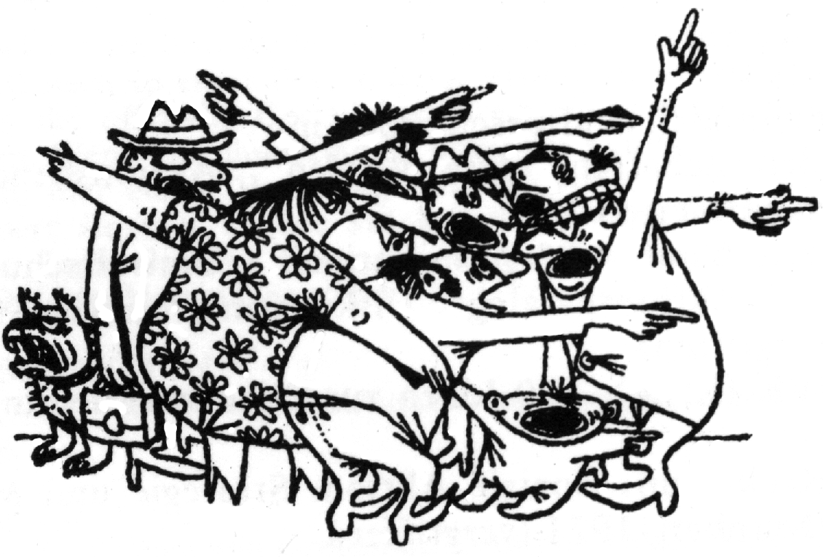
- It's essential that you build and share common ground. Most groups collapse because when the going gets tough they realise they don't have enough in common to keep working together
- Make sure that everyone knows that they are welcome to add their thoughts and ideas to the meeting agenda ad how they can do so
- During meetings, do you challenge put-downs or discriminatory remarks? Does your group have an understanding of equality of opportunity and what this means practically?
Celebration and socialising also help. When you have a success, however small, celebrate it. Thank each other for your hard work. It can remind you that campaign groups can be fun, and can re-energise the group.

For more briefings and training visit:
www.seedsforchange.org.uk
A non profit network of social change trainers.
This briefing is @nticopyright. Copy & distribute freely.

