Access Issues at Meetings

Easy access to a venue for everyone is essential for a successful community event. However, it is also extremely rare. Given that, there are things that an events organiser can do to make sure that the best use is made even of a less than perfect venue.
Gather accurate information about the venue and list all access features clearly in all your publicity - for example:
- 2 parking spaces for orange badge holders
- level entrance to the building from the car park
- stepped entrance with a handrail on the left on the street
- induction loop in meeting room
If there is poor access to a building, then say so. You don't need to apologise, say that you will lift disabled people in, or that it's "accessible with difficulty". For example: “The only entrance has three steps up, with a handrail”.
To find out about accessible venues, you could contact your local Disability Rights Forum or Coalition. Visit the venue before booking it, and check for accessibility. Here are some things to check:
- Is there a car park or any area near the front door for cars? If so, are there marked orange badge spaces? If not, consider reserving the parking spaces for orange badge holders.
- Is the "accessible entrance" kept locked? If so, this is sending a clear message to wheel chair users and people with mobility impairments that they are not wanted. Insist that the locked entrance is kept unlocked for the duration of your time in the building. Make sure that the path up to the accessible entrance is not blocked by wheelie bins, rubbish bags, advertising boards etc.
- Is the adapted toilet kept locked? If so, make sure that it is unlocked while you are in the building - it is a myth that all disabled people who need access to it have a RADAR key. Non-disabled adults do not have to ask for permission to use the toilet, so why should disabled people? Is the adapted toilet clean and free of clutter? A number of venues, regrettably, use the adapted toilet as a storeroom for equipment. Make sure this is not the case in the venue you are about to hire.
- Is there a loop system in your meeting room for hearing aid users? If so, is it working? Does anyone know how to switch it on or alter the volume? If so, will that perons be there when you hold your event in the building?
- Are there clear sign posts from the reception to the room?
- Are there any visual flashing fire alarms in the toilets to alert deaf and hearing impaired people of fire? If not, make sure you know if there are any deaf or hearing impaired people coming to the event, as you will be responsible for their safety in case of an emergency evacuation.
- Is the baby changing area accessible to disabled people? (N.B. some venues are doubling up the adapted toilet with the baby changing area - this is not good practice, as it means that the venue is less accessible to disabled people.)
- If you list the access in the publicity, disabled people will feel more confident that you know the building, that it is accessible, and that your organisation cares about access issues. Physical access to a building is only one aspect of making community work practices inclusive to everyone, but it is an important aspect.
- Event organisers will also need to sort out accessible work practices, such as making paper work accessible to visually impaired people and people with learning difficulties, booking sign language interpreters, lipspeakers or translators; and ensuring (if food is provided) - that all diets are included.
- Finally, if a disabled person complains about access to your venue, listen carefully and make a note of the difficulties so that you can either sort out the problem or add the information to future publicity.
(Adapted from ACW/CWTCo. Skills Manual 2001, Access Issues by Ruth Malkin)

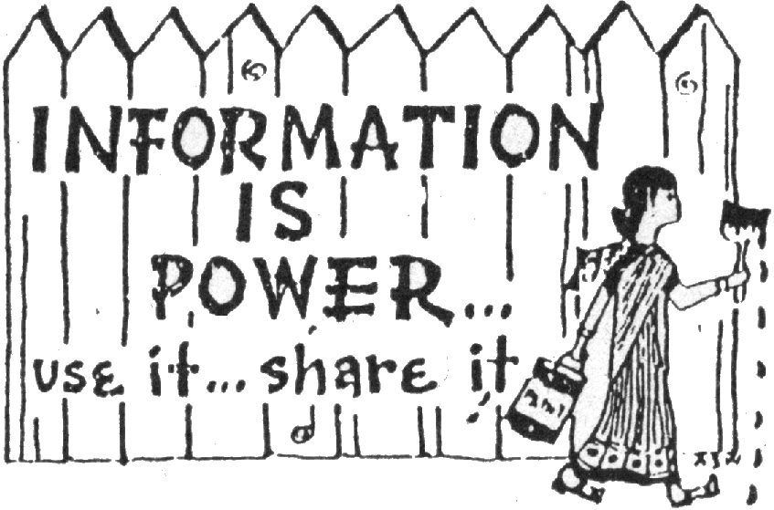
For more briefings on grassroots activism
and to find out about free workshops and training
have a look at our website:

www.seedsforchange.org.uk

Or contact us:

Seeds for Change Lancaster  96 Church St  Lancaster LA1 1TD  Tel: 0845 330 7583  lancaster@seedsforchange.org.uk  Scotland, Northern England and North Wales | Seeds for Change Oxford  16b Cherwell Street  Oxford OX4 1BG  Tel: 0845 458 4776  oxford@seedsforchange.org.uk  South East England, South West England, the Midlands and South & Central Wales
This briefing is @nti-copywrite.
Feel free to copy and distribute it!

