Making decisions by consensus

What is consensus decision making?
Consensus is a decision-making process that works creatively to include everyone involved in making the decision. Instead of simply voting for an item, and letting the majority of the group get their way, the group is committed to finding solutions that everyone can live with. This ensures that everyone’s opinions, ideas and reservations are taken into account. But consensus is more than just a compromise. It is a process that can result in surprising and creative solutions - often better than the original suggestions.

Guidelines for consensus building
- Be respectful and trust each other. Don't be afraid to express your ideas and opinions.
- Don't assume that someone must win and someone must lose. Look for the most acceptable solution for everyone.
- Think before you speak, listen before you object. Listen to others’ reactions, and consider them carefully before pressing your point.
- Remember that the ideal behind consensus is empowering versus overpowering, agreement versus majorities/minorities.
At the heart of consensus is a respectful dialogue between equals, helping groups to work together to meet both the individuals' and the group's needs. It's about how to work with each other rather than “for” or “against” each other.
Making decisions by consensus is based on trust and openness – this means learning to openly express both our desires (what we'd like to see happening), and our needs (what we have to see happen in order to be able to support a decision). If everyone is able to trust each other and talk openly then the group will have the information it requires to take everyone's positions into account and to come up with a solution that everyone can support.
It may take time to learn how to distinguish between our wants and needs: after all most of us are more used to decision-making where one wins and the other loses. In this kind of adversarial decision making we are often forced to take up a strategic position of presenting our desires as needs, allowing us to concede points without giving up any significant ground.

Who uses consensus?
Consensus is not a new idea, but has been tested and proven around the world.
Non-hierarchical societies have existed on the American continent for hundreds of years. Before 1600, five nations - the Cayuga, Mohawk, Oneida, Onondaga, and Seneca - formed the Haudenosaunee Confederation, working on a consensual basis and which is still in existence today. Each Nation within the Confederacy selects individuals to represent them at confederacy meetings. Issues are discussed until all are in agreement on a common course of action. Never would the majority force their will upon the minority. Similarly no one could force a warrior to go to war against their better judgement.
A second example of consensus based organisation is the Muscogee (Creek) Nation. The Muscogee have the oldest political institutions in North America, with a recorded history going back beyond 400 years. If consensus on a major issue could not be achieved to everyone’s satisfaction, people were free to move and set up their own community with the support - not the enmity - of the town they were leaving. This is in stark contrast to political organisation today, where the state’s need to control its citizens makes it virtually impossible for individuals disagreeing with general policy to just go and do their own thing.
Consensus can not only be found in the indigenous societies around the world but also throughout European history. Many mediaeval institutions, such as guilds, town councils, the influential Hanseatic trading league as well as governing bodies of countries (German and Polish Imperial Courts) required unity. There are also many examples of successful and stable utopian communes using consensus decision-making, such as the Christian Herrnhüter settlements 1741-1760/61 and the production commune Boimondeau in France 1941-1972. The Herrnhüter complemented the consensus system with the drawing of lots to choose the members of the community council, making intrigue and power politics superfluous. This tool for decision-making is unfortunately rarely used or discussed today, even though it can offer a fair way out of a decision-making dilemma.
Christiania, an autonomous district in the city of Copenhagen has been self-governed by its inhabitants using consensus since 1970. This includes regulating economic, cultural and educational issues, water and electricity supply, health and security.
Within the co-operative movement many housing co-ops and businesses are using consensus successfully, including making difficult financial and management decisions. A prominent example is Radical Routes, a network of housing and workers' co-ops all using consensus decision-making. Through Rootstock Radical Routes raises and loans out substantial sums of money to member co-ops.

How does Consensus work?
For good consensus building to be possible a few conditions need to be met:
Common goal: Everyone at the meeting needs to be united in a clear common goal – whether it's the desire to take action at a specific event, or a shared ethos. Being clear about the shared goal helps to keep a meeting focused and united.
Commitment to reaching consensus on all decisions: Consensus requires commitment, patience, tolerance and a willingness to put the group first. It can be damaging if individuals secretly want to return to majority voting, just waiting for the chance to say “I told you it wouldn't work.”
Trust and respect: We all need to trust that everyone shares our commitment, and respects our opinions and equal rights.
Clear process: Everyone needs to understand the process for making decisions you are using. There are lots of variations of the consensus process, so even if people are experienced in using consensus they may use it differently to you! Explain the process at the beginning of the meeting.
Active participation: If we want a decision we all can agree on, we all need to play an active role in the decision-making.
Good facilitation: Facilitation helps to ensure that the group works harmoniously, creatively and democratically. When your group is larger than just a handful of people or you are trying to make a difficult decisions appoint facilitators to help your meeting run more smoothly.

The Consensus Process
The dialogue that helps us to find the common ground and respect our differences can take lots of different formats. Some groups have developed detailed procedures, whereas in other groups it may be an organic process. What process you use depends on the size of the group and how well people know each other. Below we have outlined a process for group no larger than 15-20 people. Later on we will discuss the spokescouncil process, which works for groups of hundreds and even thousands of people.

A model of small group consensus
Discuss the pros and cons of the proposal - make sure everybody has a chance to contribute. Are there any friendly amendments to the proposal that make it more acceptable to the group?
Introduce the issue, provide clarification and define question(s) to be decided.

Gather initial thoughts and reactions. What are the issues and concerns?
Collect ideas and proposals for solving the problem and write them down.
Test for agreement:
☞Are there any major objections that you can't overcome?
☞ Acknowledge minor objections
☞Check for agreement
Do we have consensus?
Discuss the ideas - What are the pros and cons? Modify some proposals, eliminate others and develop a short-list of favourites.

Implement the decision
Look for a way to bring together the best qualities of the remaining ideas. Create a proposal out of the ideas you have left.

What if we cannot agree?
Consensus aims to reach a decision that everyone can live with. So what can be done when we need to reach agreement and we seem to be poles apart?
To find a solution that works for everyone we have to understand the underlying problems that lead to the differing points of view and then come up with ways of addressing them: there are often specific problems causing the failure to reach agreement. These can often be dealt with by facilitation and are explored later in this chapter.
For those times when there is continued disagreement over a decision that needs to be taken consider the following options:
The major objection (block or veto): Using your veto will stop the proposal going ahead, so think carefully before doing it. But don't be afraid to veto when it's relevant. A veto means: “ If this decision went ahead I could not be part of this project.” If someone expresses a major objection, the group discards the proposal and starts working on a new one. People often ask what happens if the rest of the group is unwilling to respect the veto. This is a difficult situation where the group needs to decide whether the proposal is so important to them that they will risk the person objecting leaving the group. The ideal is never to be in a situation where a major objection is being raised in the first place: the key to consensus building is to identify areas people feel strongly about early on in the process, so that any proposals already them them into account.
The minor objection (stand aside): There will be times when you want to object, but not to veto. In those situations you can 'stand aside'. Standing aside registers your dissent, and says clearly that you won't help implement the proposal. A stand aside means: “I personally can’t do this, but I won’t stop others from doing it.” The person standing aside is not responsible for the consequences, but also isn't stopping the group from going ahead with the decision. Stand asides should be recorded in the minutes.
It can really help both the group and individuals to understand the clear distinction between minor and major objections. When someone vetoes a proposal it is always advisable to first check whether they would be able to stand aside rather than block the whole group from going ahead.
Agree to disagree: The group decides that no agreement can be reached on this issue. Imagine what will happen in six months, a year, five year’s time if you don’t agree. Is the decision still so important?
The Fridge: Put the decision on ice, and come back to it in an hour, a day or a week. Quite often when people have had a chance to cool off and think it through things can look quite different.
Back-up options: Some groups have fall-back options when no agreement can be reached.
- Allow the person most concerned to make the decision.
- Put all the possibilities into a hat and pull one out. Agree in advance on this solution.
- Some groups have majority voting as a backup, often only after a second or third attempt at reaching consensus and requiring an overwhelming majority such as 80 or 90%.
Leaving the group: If one person continually finds him/herself at odds with the rest of the group, it may be time to think about the reasons for this. Is this really the right group to be in? A group may also ask a member to leave.

Facilitating the consensus process
Facilitation helps a group to have an efficient and inclusive meeting. Facilitator are essentially helpers for the meeting. They look after the structure of the meeting, making sure everyone has an opportunity to contribute, and decisions are reached.
Facilitation is a vital role that needs to be filled at every meeting. In small groups this function may be shared by everyone there, or rotated informally. Difficult meetings or meetings with a larger number of participants (more than 8 or 10 people) should always have clearly designated facilitators. However all members of the meeting should always feel responsible for the progress of the meeting, and help the facilitator if necessary.
What the dictionary says:
Facilitation \Fa*cil`i*ta"tion\, n. making easy, the act of assisting or making easier the progress or improvement of something.
Depending on the group a facilitator might:
- help the group decide on a structure and process for the meeting and to keep to it
- keep the meeting focussed on one item at a time until decisions are reached
- regulate the flow of discussion – drawing out quiet people and limiting over-talking
- clarify and summarise points, test for consensus and formalise decisions help the group in dealing with conflicts.

Facilitation roles
One facilitator is rarely enough for a meeting. Depending on the size of the group and the length of the meeting some or all of the following roles may be used:
- The facilitator helps the group decide on and keep to the structure and process of the meeting. This means running through the agenda point by point, keeping the focus of the discussion on one item at a time, regulating the flow of the discussion and making sure everyone participates. The facilitator also clarifies and summarises points and tests for consensus.
- The Co-facilitator provides support such as writing up ideas and proposals on a flip chart for all to see or watching out for rising tension/lack of focus/flagging energy. She can also step in and facilitate if the facilitator is flagging, or feels a need to take a position on an issue.
- Keeping a list of speakers and making sure they are called to speak in turn can either be taken on by the co-facilitator or it can be a separate role.
- The minute taker notes down proposals, decisions and action points for future reference. They also draw attention to incomplete decisions - for example who is going to contact so and so and when?
- The timekeeper makes sure each agenda item gets enough time for discussion, and that the meeting finishes at the agreed time.
- The doorkeeper meets and greets people on the way into the meeting, checks that everyone knows what the meeting is for, and hands out any documents such as minutes from the last meeting. This makes new people feel welcome, and brings latecomers up to speed without interrupting the meeting.

Common problems and how to overcome them

Consensus can be time consuming
Problem 1
Tom, with lots of experience, confidence and a loud voice, is talking all the time and dominating the meeting. Hardly any one else gets a chance to speak.
Underlying causes
- Tom's lack of understanding of the consensus process, coupled with an unwillingness of the rest of the group to challenge his behaviour.
Possible solutions
The facilitator can equalise speaking time through using tools such as:
- introducing a go-round: each person speaks in turn for a set amount of time.
- at the beginning of the meeting setting a limit on how many times a person can speak
- pro-actively asking other people for their opinion: “Thank you, Tom, for your great ideas. What do other people think?”
Since it is a lengthier process to look at ideas until all objections are resolved, your group meetings may be longer and some decisions might regularly take more than a week to decide. However consensus need not involve everyone at every stage of the process:
- Get a small group, or even a pair, to go away and synthesise the discussions and brainstorms of the whole group into a few possible solutions to be discussed later by the whole group.
- Split up the meeting to deal with several issues in parallel and come back with a platter of proposals. This can speed up the meeting threefold or more.
- Not every decision needs to involve the whole group. Set up working groups on different areas, such as publicity, fund-raising, research. These sub-group can decide the nitty-gritty business that they are responsible for, within certain limits defined beforehand.

Time pressure
Time pressure to find a solution to an urgent problem leads to stress and group pressure “to just get on with it”.
- Try to make sure enough time is allowed in the agenda to tackle all issues adequately. Prioritise which decisions need to be taken there and then and which ones can wait a while.
- You could also try to find a temporary solution.

Overuse/underuse/misuse of the right to veto
Actively participating in groups can be hard enough, and using a veto more so, particularly for people who don't feel so confident in groups. It can involve standing up to – perceived or actual – group pressure and impatience. Many people are tempted to keep quiet (at least in a vote they can raise their hand) and important discussions are sometimes avoided.
In the hands of those used to more than their fair share of power and attention, the veto can be a lethal tool. It can magnify their voices, and be used to guard against changes that might affect their power base and influence.
Problem 2
People are coming up with lots of ideas, but the discussion is going nowhere. People keep going off on tangents.
Underlying causes
- Lack of structure and focus for the discussion.
- Weak facilitation.
Possible solutions
The discussion can be moved on from its creative phase to making decisions through:
- Writing all ideas up on a flip chart for all to see.
- Discussing one idea at a time, recording pros and cons for each one.
- When people bring up tangential issues, record them for discussion later. Avoid getting side-tracked.
- Checking if the facilitator needs a break or support.
In a well functioning group vetoes should be rarely if ever seen - not only because they are a last resort, but also because ideally a member's unhappiness should be picked up on before before it gets to a veto stage.
- Try to uncover the group dynamics at work. The way people behave in groups generally reflect some hidden needs or past experiences.
- Work on creating a safe atmosphere. Challenge put-downs, discriminatory and aggressive behaviour. Make use of facilitation as a tool for involving all members of the group equally.
- Don’t be afraid of making modifications to your consensus procedure. Some groups allow the possibility of falling back on an overwhelming majority vote or on drawing lots, if an issue cannot be resolved by consensus.

The group is too large.
For groups of more than 15-20 people it is advisable to split into sub groups for meaningful discussion. This is discussed below, or for a more detailed discussion of possible processes have a look at our briefing Consensus in Large Groups.
These two examples show how important it is to get to the bottom of the underlying issues when things get tricky in a meeting. Develop your ability to spot problems and the underlying reasons for them and to learn how to deal with them. The more trust and understanding there is in a group the easier it will become to overcome such problems. Facilitation can help with supplying the tools to avoid problems in the first place and to deal with them creatively if they do occur.

Tools for meetings
Here is a selection of tools you can use at various stages of the meeting to make them efficient and enjoyable for all. It is a good idea to always explain to people what tools you are using and why. In most meetings it is the job of the facilitator to work out what tools to use when.

At the beginning of the meeting
Setting up the meeting venue: It's important that the space, and the way you use the space doesn't isolate or alienate anybody. Is everyone able to hear and see clearly? Some rooms have very bad acoustics that require people to shout to be heard. Others have fixed seating or columns that restrict people's view and their ability to participate. Is the venue accessible to everyone?
Group agreements and ground rules: Agree at the beginning of the meeting on how the meeting will be run. This prevents a lot of problems from occurring in the first place. It also makes it easier for the facilitators to challenge disruptive behaviour, as they can refer back to “what we all agreed”. Possible ground rules might include: using consensus; hand signals; not interrupting each other; active participation; challenging oppressive behaviour; respecting opinions; sticking to agreed time limits and switching off mobile phones.
Clear agendas can help make a meeting flow more easily. Sort out the agenda at the start of the meeting, or even, with the participation of the group, in advance. Be realistic about what can be achieved in the time you've got, and decide which items can be dealt with at a later meeting. Set time limits on each agenda item to help the meeting end on time. Make sure that everyone has an up to date copy of the agenda or write it up on a flip chart for everyone to see. This helps to keep the discussion on topic.

Using hand signals can help meetings run more smoothly and helps the facilitators spot emerging agreements. It is important to explain what hand signals you will be using at the start of the meeting to avoid confusion!
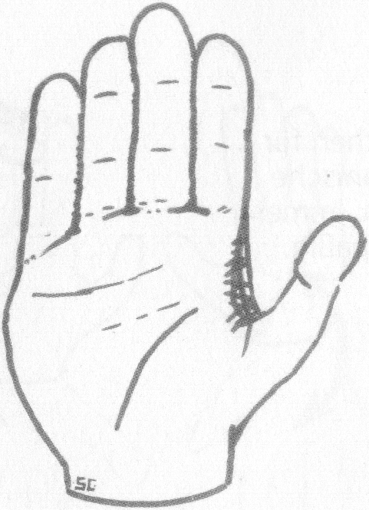
I want to contribute to the discussion
Raise a hand or forefinger when you wish to contribute to the discussion.
Technical point
Make a T-shape with your hands to indicate a proposal about the process of the discussion, e.g. “lets have a break”.

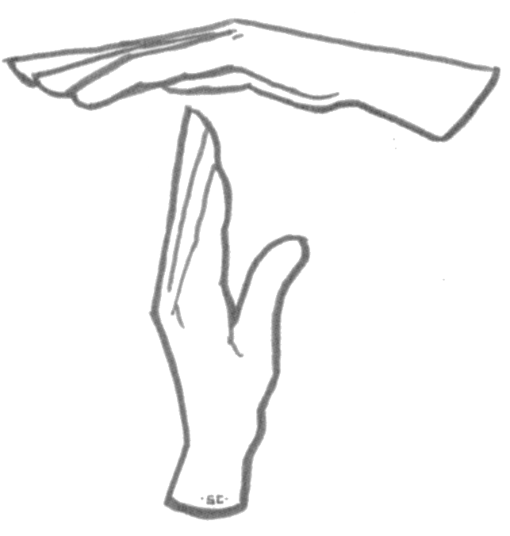

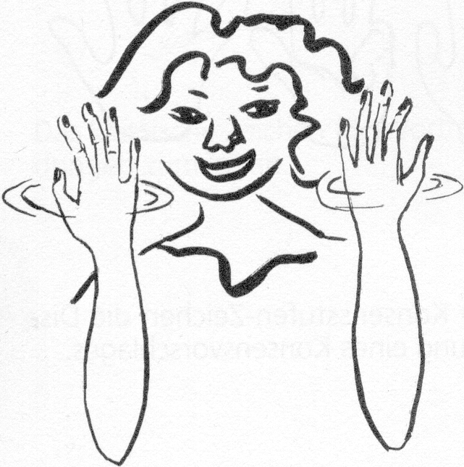
‘I agree’ or 'Sounds good!'
Silent Hand clapping. Wave your hands with your fingers pointing upwards to indicate your agreement. This gives a very helpful visual overview of what people think. It also saves time as it avoids everyone having to say “I’d just like to add that I agree with…”.

When making a decision
Not every tool is suitable for every stage of the consensus process. Think carefully about when you would use which tool and why.
Go-rounds: Everyone takes a turn to speak without interruption or comment from other people. Go-rounds help to gather opinions, feelings and ideas as well as slowing down the discussion and improving listening. Make sure that everyone gets a chance to speak.
Idea storm: Ask people to call out all their ideas as fast as possible - without censoring them. All ideas are welcome - the crazier the the better. This helps people to be inspired by each other. Have one or two note takers to write all ideas down where everyone can see them. Make sure there is no discussion or comment on others' ideas at this stage. Structured thinking and organising can come afterwards.
Show of hands or straw poll: An obvious but effective way of prioritising items or gauging group opinion. Make sure people understand this is not voting, but to help the facilitators spot emerging agreements.
Clear process: when dealing with multiple proposals. For example, if you plan to consider ideas in turn, let people know they'll all be considered and given equal time. Otherwise some people may well be uncooperative because they can't clearly see that there is time set aside to talk about their idea and they feel like they're being ignored. If you're putting some ideas to one side, after a prioritisation exercise for example, you might like to ensure their 'owners' have agreed and understand the reasons why.
Pros & Cons: Got several ideas and can't decide which one to go for? Simply list the benefits and drawbacks of each idea and compare the results. This can be done as a full group, or by asking pairs, or small groups to work on the pros and cons of one option and report back to the group.
'Plus-Minus-Implications': A variation of the simple 'pros & cons' technique. It will help you decide between a number of options by examining them one by one. Create a simple table with three columns titled Plus, Minus, and Implications. In the Plus column write down the positive consequences of the option. In the Minus column write any negative consequences of the action, and in the Implications column write down other possible implications whether good or bad.
Breaks: taking a break can revitalise a meeting, reduce tension, and give people time to reflect on proposals and decisions. Plan in a 15 minute break at least every 2 hours and take spontaneous breaks if the meeting gets too heated or attention is flagging.

At the end of a meeting:
Evaluation and constructive feedback: evaluation allows us to learn from our experiences. It should be a regular part of our meetings and workshops as it give us the chance for honest feedback on the process and content of the event, allowing us to improve in the future. Everyone who participated in an event should be encouraged to take part in its evaluation.

Consensus in large groups – the spokescouncil

When making decisions in a large group there is a tendency to have one large meeting with hundreds of people. One of the problems with this format is that the large majority of people does not have a chance to speak due to time constraints, instead it is usually dominated by a few confident people. This is not a good starting point for reaching consensus which depends on mutual understanding and trust. Good consensus building is based on working in small groups where everyone contributes to the discussion.
The spokescouncil was developed to address this problem. It enables large numbers of people to work together as democratically as possible, allowing the maximum of opinions and ideas to be heard in an efficient way. Many groups such as social centres and large workers' co-ops as well as peace, anti-nuclear and environmental movements around the world use this process successfully.

How a spokescouncil works
In a spokescouncil the meeting breaks up into smaller groups to allow everyone to express their views and take part in discussions.
Typical Spokescouncil
Spokes
Small groups can be either based on working groups, in regional groupings or a group based on shared political analysis or even be entirely random.
People in each small group discuss the issues and come up with proposals and concerns.
Each group then sends a delegate (or spoke) to the spokescouncil meeting, where all the spokes present the proposals and concerns of their group. The spokes then come up with proposals that they think might be acceptable to everyone and check back with their groups before a decision is taken. A group can also empower their spoke to take decisions within certain parameters.
Groups clustered behind spoke
For a spokescouncil to work effectively the role of the spoke needs to be clearly defined. A group can choose to use the spoke as a voice – feeding back to the group the collective, agreed thoughts. Or the small group might empower their spoke to make certain decisions based on their knowledge of the small group. Being the spoke is not easy – it carries significant responsibility. You might like to rotate the role from meeting to meeting, or agenda item to agenda item. It also helps to have two spokes, one of them presenting the viewpoints and proposals of their small group, the other to take notes of what other groups have to say. This helps to ensure that ideas don't get lost or misrepresented in the transmission between small groups and the spokescouncil. Spokescouncils require good facilitation, by a team of at least 3 facilitators that work well together and who are skilled at synthesising proposals.
Conclusion
Consensus is about participation and equalising power. It can also be a very powerful process for building communities and empowering individuals. Despite sometimes taking longer to achieve consensus can actually save time and stress, because the group doesn't have to keep revisiting past decisions - because they were fully supported at the time they were made. Don't be discouraged if the going gets rough. For most of us consensus is a completely new way of negotiating and making decisions – it takes time to unlearn the patterns of behaviour we have been brought up to accept as the norm. Consensus gets much easier with practice, and its true potential is often only recognised after a difficult decision has been reached in a way that everyone is happy with.

Further Reading
Try your local library first - they are generally quite happy to order or even buy books for you. If you decide to buy a book, get it from one of the radical/independent bookshops - they all do mail order! In the UK try News from Nowhere in Liverpool (0151 708 7270) or Housmans Bookshop in London (020 7278 4474).

Seeds for Change: www.seedsforchange.org.uk Lots of guides to different forms of Consensus Decision-making and Facilitation
Rant Collective: www.rantcollective.net US based activist trainers, with resources and information on their website.
Resource Manual for a Living Revolution, V.Coover, E.Deacon, C.Esser and C.Moore; New Society, 1981. A complete manual for developing your group – goes well beyond decision making. Sadly out of print now, but its worth trying to get your hands on a copy!
Facilitator's Guide to Participatory Decision-Making, S.Kaner with L.Lind, C.Toldi, S.Fisk and D.Berger, New Society, 1996, ISBN: 0-86571-347-2
From Conflict to Cooperation - How to Mediate A Dispute, Dr B.Potter; Ronin Publishing, 1996, ISBN: 0-914171-79-8
The Mediator's Handbook, J.Beer with E.Stief; New SocietyPublishers, 3rd edition, 1997, ISBN: 0-86571-359-6, developed by Friends Conflict Resolution Programs
Working with Conflict, Fisher et al; Zed Books, 2000, ISBN: 1 85649 837 9
The Tyranny of Structurelessness, J.Freeman, http://www.struggle.ws/anarchism/pdf/booklets/structurelessness.html; Pamphlet about informal hierarchies in small groups

This briefing is @nti-copyright. Feel free to copy and distribute it!
More at www.seedsforchange.org.uk

