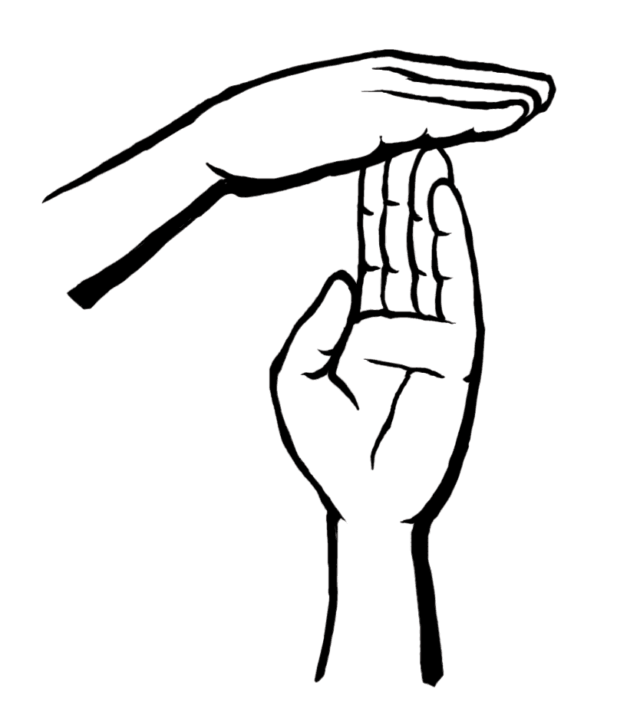
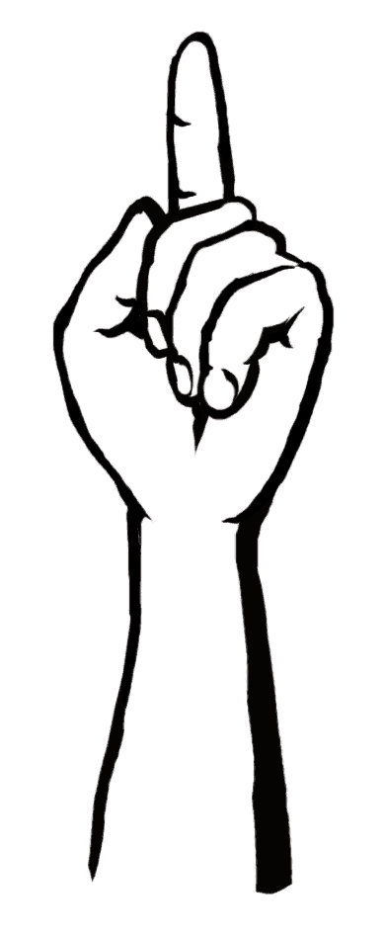
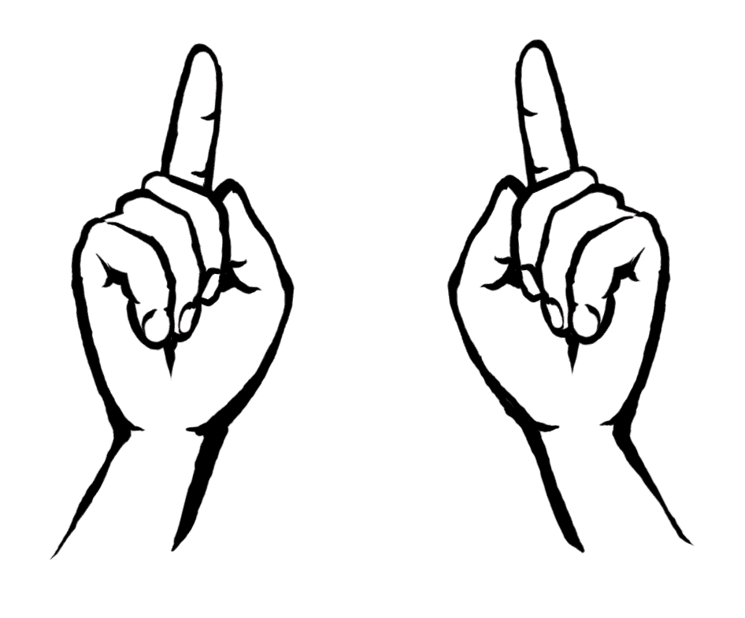
Hand signals
A simple technique that can make meetings run more smoothly and help the facilitator spot emerging agreements.
I want to contribute to the discussion
Raise a hand or forefinger when you wish to contribute to the discussion.
Below are some commonly used hand signals. Remember that handsignals are a way to make meetings more participatory, inclusive and effective – avoid using them as a way of putting others down.
Language
Make an L - shape with your thumb and forefinger to request translation or to ask the speaker to use less complex language.
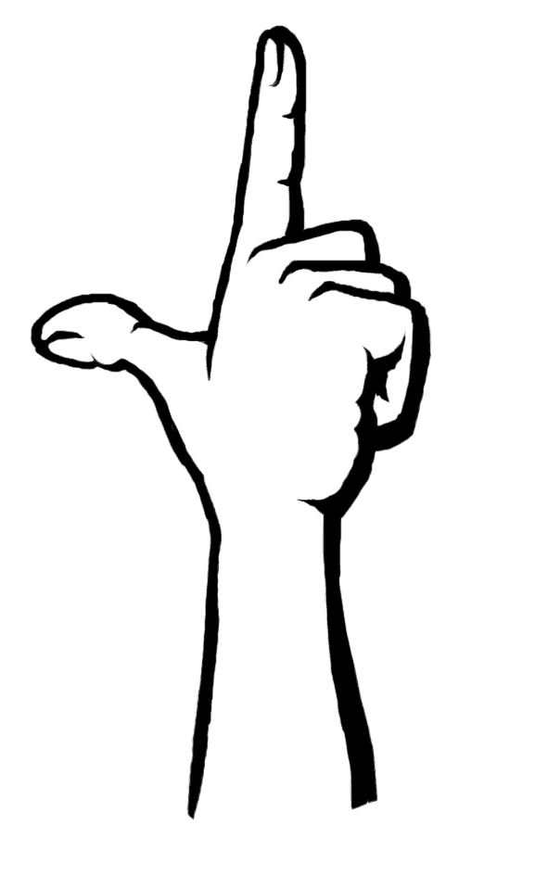
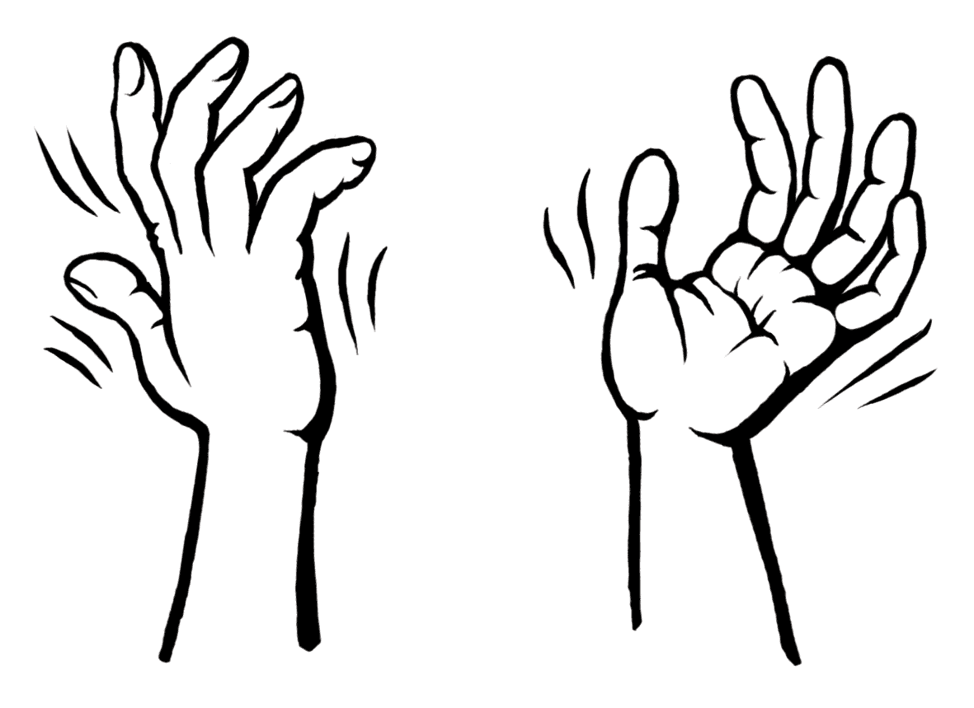
‘I agree’ or 'Sounds good!'
Wave your hands with your fingers pointing upwards to indicate your agreement. This gives a very helpful visual overview of what people think. It also saves time as it avoids everyone having to say “I’d just like to add that I agree with…”.

Many facilitators prefer to restrict the number of hand signals used to those
shown above, but the following are also commonly seen.

Technical point
Make a T-shape with your hands. Indicates a proposal about the process of the discussion, such as “let's discuss this in small groups” or “lets have a break”.
Direct response
Raise both forefingers if your point is directly relevant. This allows you to jump to the head of the queue, in front of everyone raising just one finger. This is open to abuse and requires strict facilitation.

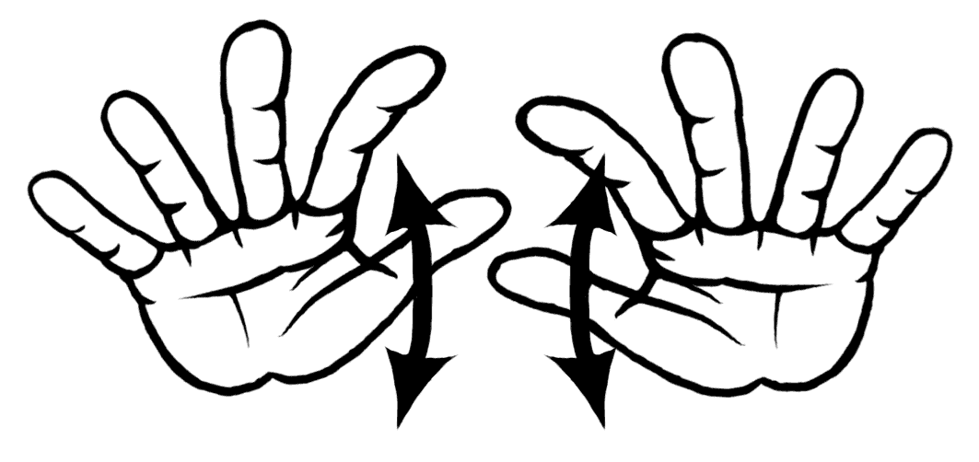
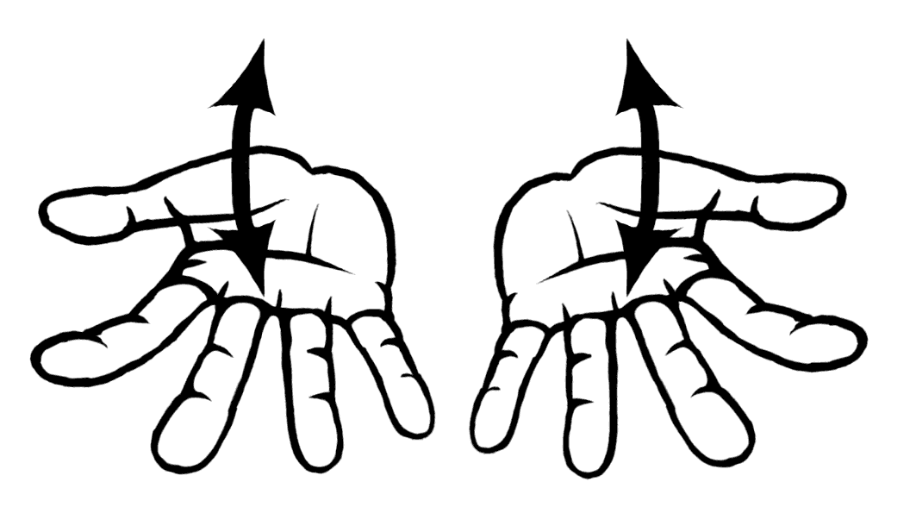
Speak Up
Wave your hands upwards to ask the speaker to speak louder. Very helpful in large groups.
Slow down
Wave your hands downwards if you want the speaker to slow down. Important for international meetings when translation is going on.

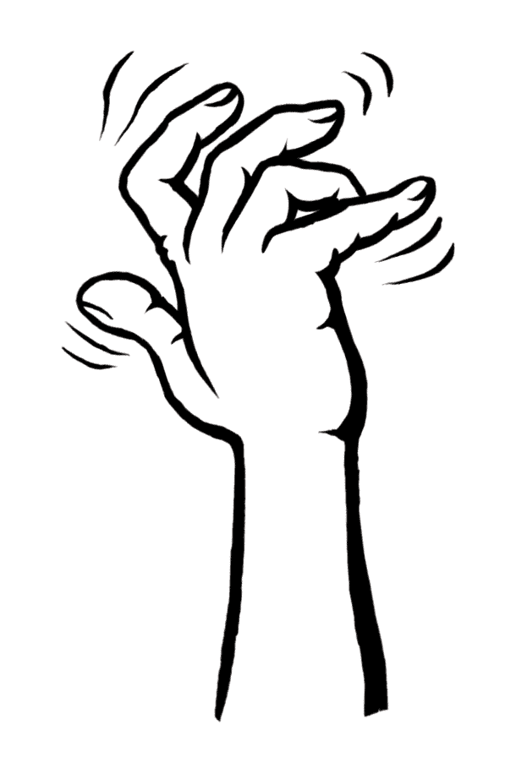
For more briefings and to find out about training workshops look at our website: www.seedsforchange.org.uk
This briefing is @nticopyright - copy & distribute freely!
I'm confused
Wriggle your fingers in front of your face if you want to tell the speaker and facilitator that you don't understand the content of the discussion.

