Facilitation of Meetings

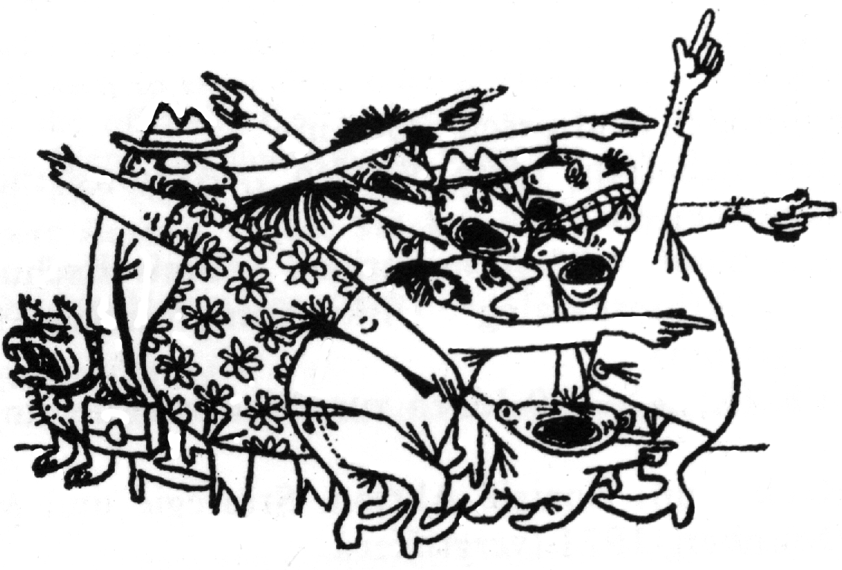
Meetings are a necessary part of working in groups – they give us the chance to share information, to reach decisions and to get jobs done. But too often they drag on and on, with tempers running high, people talking over each other, and no decisions being made. Bad meetings often leave you wondering why you bothered turning up. Unfortunately this pattern is very common in groups. It leads to frustration, ineffectiveness and loss of group members. However by using some facilitatation skills it's easy to turn around the style of meetings and actually make them an enjoyable and inspiring experience.

What is a Facilitator?

Was the meeting successful?
A good facilitator balances:
Tasks – What got done? Did you get the needed results? Did problems get solved and things planned to meet the objective of the group?
Maintenance – How did the tasks get done? How did people feel and how will this affect morale and group cohesion? Did the meeting make good use of the pooled talents? Was it enjoyable?
A facilitator is essentially a helper for the group to have an efficient and inclusive meeting. A facilitator might:
- help the group decide on a structure and process for the meeting
- keep the meeting focused on one item at a time until decisions are reached
- regulate the flow of discussion – drawing out quiet people and limiting those who talk to much
- clarify and summarise points and test for agreement
- help the group deal with conflicts.

A good facilitator stays neutral, winning the trust of the group. A facilitator never “directs” the group without its consent. At no time do they make decisions for the group, or take on roles which are the responsibility of the group as a whole.

A Facilitator's Skills and Qualities
Good listening skills including strategic questioning to be able to understand everyone's viewpoint properly.
Little emotional involvement in the issue being discussed. It's essential to stay neutral and not manipulate the meeting towards a particular outcome. If this becomes difficult, step out of role and let someone else facilitate

Understanding what the meeting wants to achieve, as well as long-term goals of the group.
Sensitivity - How are people feeling?

Assertiveness - knowing when to intervene decisively and give some direction to the meeting.

Respect for all participants and an interest in what each individual has to offer.

Other roles at a meeting
To make the job of the facilitator easier you can introduce other roles to a meeting.
- Instead of just one facilitator you could have two or more co-facilitators. These are able to take turns facilitating and give support to each other.
- The person not actively facilitating can also pay more attention to the emotional atmosphere of the meeting and look after how individual members are affected. This is often called vibeswatching.
- Another role is the timekeeper who draws attention to the agreed time frame for the meeting and keeps the group to it, negotiating extensions if needed.
- Notetakers or recorders keep track of decisions, take minutes, collect reports, and also draw attention to incomplete decisions – for example who is going to contact so and so, and when?
- The doorkeeper sits by the door and welcomes newcomers and latecomers, making sure everyone understands the purpose of the meeting and anything they have missed. The doorkeeper also makes sure everyone knows practical details, like where to get a cup of coffee and where the toilets are.


Facilitation Tools

A facilitator might introduce 'facilitation tools' into a meeting to help the group work effectively and encourage everyone to participate. Common tools are things such as ideastorming, go-rounds or small group discussion. Our Briefing Facilitation Tools for Meetings has more ideas.

Glossary of Common Tools
Ideastorming - A way of quickly gathering a large number of ideas. Start by stating the issue. Ask people to say whatever comes into their heads as fast as possible - without censoring it. This encourages creativity and frees energy. Write down all ideas for later discussion.
Go-rounds - Everyone takes a turn to speak without interruption or comment from other people. Go-rounds help to gather opinions, feelings and ideas as well as slowing down the discussion and improving listening. Make sure that everyone gets a chance to speak.
Small Groups – It can be useful to break down into small groups for some discussions. Some people feel safer and more able to contribute to a small group. You can also get more done if each group explores a different task and then reports back.
Paired Listening – For when you want a high quality of listening, or to give people time to reflect on their ideas before a full discussion. Get people into pairs and ask them to listen to each other uninterrupted for a few minutes each. You can then feedback thoughts to the full group.
Energisers - When people stop concentrating or become irritable in a meeting, it could simply be because they've been sitting and listening for too long. A stretch or a game, can re-energise people. Games also help people to get to know each other better and lift the spirits in the group. Be sensitive to the group and individual members - the idea is to relax people, not to make them feel embarrassed or isolated. Also be aware of mobility issues.
Parking Space – To make sure all ideas get recorded and no-one feels like they've been ignored. Whenever anything comes up that's not relevant to the discussion at hand “park” it on a large sheet of paper on the wall and deal with it later. This allows you to stay focused but reassures people that their idea will not be forgotten.

Some facilitation tasks
p Planning the meeting agenda and thinking about the time and the order of agenda items p Preparing the room so it's comfortable and everyone can take part p Bringing materials the meeting might need, like paper and pens p Introducing the meeting and warming the group up p Keeping the discussion to time p Challenging aggressive or oppressive behaviour p Looking to see who wants to speak next p Making sure everyone gets a chance to contribute p Clarifying any confusion and making sure everyone understands the discussion p Dealing with conflicts p Getting clear decisions made p Keeping the group focused and energised p

Top Tips for Facilitators
- Design a good agenda. Set time limits and tackle all points.
- Watch both for content and process (task and maintenance).
- Keep the group moving towards its aims.
- Use lots of facilitation tools.
- Get the best possible contribution from everyone.
- Create a safe and empowering atmosphere.
- Put a stop to domineering, interrupting, put-downs and guilt trips.

For more briefings on grassroots activism, and to find out about training workshops look at our website:

www.seedsforchange.org.uk

Or contact us:
Seeds for Change Lancaster
lancaster@seedsforchange.org.uk v 0845 330 7583

Seeds for Change Oxford
oxford@seedsforchange.org.uk v 0845 458 4776

A non profit network of social change trainers

This briefing is @nticopyright - copy & distribute freely

