Facilitation of Meetings

Have you ever sat through a meeting that has dragged on and on, with tempers running high, people talking over each other and no decisions being made? Or one person dominating the whole meeting and making all the decisions, leaving you to wonder why you bothered turning up? Most of us can manage sitting through such a meeting for a couple of times, but then start finding excuses not to go anymore, or at least wish we didn't have to. Unfortunately this pattern is very common in groups of all kinds. It leads to frustration, ineffectiveness and eventually loss of group members.

However with the goodwill of the group it is quite easy to turn around the style of meetings and actually make them an enjoyable and inspiring experience for everyone. This briefing explores the concept of Facilitation and how it can help in creating successful and positive meetings.

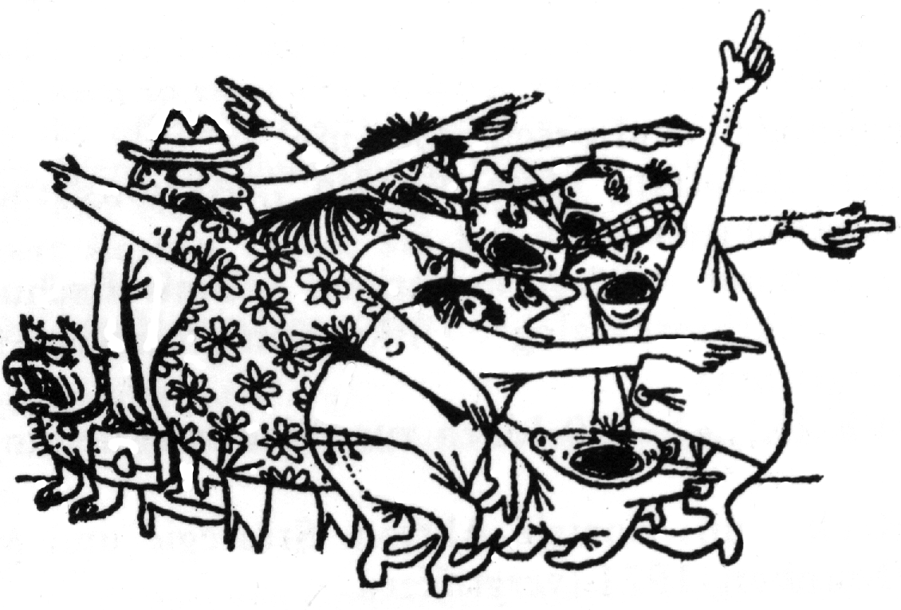
This briefing is aimed at groups using consensus based decision-making, a process that involves all members of the group in reaching an agreement that is acceptable to everyone. However, facilitation can also be used for other decision-making methods such as voting. Of course it's not just useful for decision-making meetings. Facilitation helps any meeting work more effectively. To find out more about consensus decision making please have a look at our consensus briefings. For a discussion of tools used in facilitation please refer to the briefing Facilitation Tools for Meetings. (see our website: www.seedsforchange.org.uk).
Terms in italics are explained in the glossary.

The role of meetings in group work

Meetings are a necessary part of working in any group – they give us the chance to share information, to reach decisions and to get jobs done. However, meetings have another important function, which is often forgotten about - group maintenance. A good meeting not only gets work done, but also involves, supports and empowers the participants, creating a high level of energy and enthusiasm. A sense of community and connection to fellow group members is the basis for successful group work and social change. Good facilitation will help you to achieve all of this.
Was the meeting successful?
Tasks – what got done? Did you get the necessary results? Were problems solved, and were the objectives of the group met?
Maintenance – How did it get done? How did people feel and how will this affect morale and group cohesion? Did the meeting make good use of the pooled talents? Was it enjoyable?
What is Facilitation

Facilitation is about helping the group to have an efficient and inclusive meeting. Facilitation is a series of roles. These are often embodied in one person – the facilitator - but we'd encourage groups to think in terms of shared facilitation, with everyone sharing the responsibility for ensuring a meeting is well run, productive and participative. Facilitation tasks include :
- help the group decide on a structure and process for the meeting and to keep to it
- keep the meeting focussed on one item at a time until decisions are reached
- regulate the flow of discussion – drawing out quiet people, or those with the most relevant expertise, and limiting those who tend to do all the talking
- clarify and summarise points, test for consensus and formalise decisions
- help the group in dealing with conflicts
- keep the meeting to time
- ensure that a written record is made of any action points and decisions agreed at the meeting

To ensure that the group is using the most effective means of working through topics the facilitator might introduce tools such as ideastorming, go-rounds or small group discussion. See our Briefing on Facilitation Tools for Meetings for an overview of such tools.

Facilitation is a vital role that needs to be filled at every meeting. In small groups this function may be shared or rotated informally. Whilst difficult meetings or meetings with a larger number of participants (more than 8 or 10 people) should always have a clearly designated and experienced facilitator, all members of any meeting should feel responsible for the progress of the meeting, and help the facilitator if necessary.

Facilitating or Chairing?

Superficially a facilitator fills a role similar to that of the traditional chairperson. There are however important differences. A facilitator never “directs” the group without its consent. At no time does the facilitator make decisions for the group or take on functions which are the responsibility of the group as a whole. A good facilitator stays neutral and helps the members of the meeting be aware that it is their business that's being conducted. The success of the meeting is the mutual responsibility of the whole group. The facilitator needs to be aware of this and always get the group’s agreement before using processes or tools
What the dictionary says:
Facilitation \Fa*cil`i*ta"tion\, n. making easy, the act of assisting or making easier the progress or improvement of something.

Learn to facilitate

The role of facilitator can be learnt by everyone. Use your own experience of meetings and observe other facilitators. Learn from mistakes, from bad meetings as well as good ones. If the role of facilitator is rotated amongst group members, people can develop these skills. It is well worth running some training, aside from normal meeting times, to practice facilitation skills. These skills are not only useful in group meetings but also in informal settings, at work and at home.
Be aware that individual behaviour in groups is influenced by individual needs and past positive and negative experiences in groups. Try to spot your own negative behaviour patterns and work on identifying your own and other people's needs.
A Facilitator's Skills and Qualities

Remaining neutral on the issues discussed. Avoid manipulating the meeting towards a particular outcome. If this becomes difficult, step out of role and let someone else facilitate.
Energy and attention for the job at hand.
Understanding of tasks for the meeting as well as long-term goals of the group.

Confidence that good solutions will be found and consensus can be achieved.
Good listening skills including strategic questioning to be able to understand everyone's viewpoint properly.

Assertiveness - know when to intervene decisively and give some direction to the meeting.

Respect for all participants and interest in what each individual has to offer.

Clear thinking and observation Attend both to the content of the discussion and the process. How are people feeling? What is being said?

Co-facilitation roles at a meeting
Instead of just one facilitator you could have two or more co-facilitators. Not only does this share out more of the facilitation tasks amongst the group, it will also make the job of facilitating a lot easier and less intimidating! It is however important that co-facilitators agree, before the meeting, what their exact roles in the meeting are and under what circumstances they will change roles.
Co-facilitators are able to take turns facilitating and give support to each other. This is useful if the facilitator needs to step out of his/her role in order to participate in the discussion, or to have a break, or when back-up is needed in cases of tension, conflict or confusion. Also four ears hear more than two, so a co-facilitator is a useful sounding board to check you're in tune with what the meeting is saying.
If the meeting is large a facilitator may need help keeping track of whose turn it is to speak next. One of the co-facilitator can take on the job of keeping a speaking list, and of giving time limits to speakers.
Someone not actively facilitating can also pay more attention to the emotional atmosphere of the meeting and look after how individual members are affected. This is sometimes called vibeswatching. In situations of conflict and distress the vibeswatcher will intervene, for example by taking the role of an intermediary, by taking time out with someone and listening to them or by suggesting breaks and tools to improve the atmosphere of the meeting. To be a good vibeswatcher you need to be able to sense underlying feelings - listen carefully and be aware of body language.
Another role that supports the facilitator is that of timekeeper. The timekeeper draws attention to the agreed time frame for the meeting and keeps the group to it, negotiating extensions for particular agenda items, or for the meeting as a whole, if needed.
Minutetakers play a vital role at meetings: they keep track of decisions, take minutes, collect reports, and also draw attention to incomplete decisions – for example who is going to contact so and so, and when?
A doorkeeper can be useful in public meetings, or where some people are expected to be late. The doorkeeper can welcome newcomers or latecomers and bring them up to speed on the meeting – it's main purpose, what has been covered so far in the agenda, how decisions are being made, as well as the practical 'housekeeping' information such as the location of the toilets. Having a doorkeeper can prevent having to interrupt the flow of a meeting to recap everytime someone enters the room.
In very large meetings it is advisable to have a co-ordinator, who is responsible for the venue, equipment, refreshments and notices. The co-ordinator can also gather people together to start on time.

Facilitating a Meeting - Beginning to End

This section gives an overview of the possible tasks of a facilitator in a meeting. It is important to be aware that every meeting is different. Not all the points mentioned may be appropriate – use your own judgement and innovation. Make sure that the goals of the group and members' expectations of the facilitator are clear to everyone. This allows the appropriate use of tools and suggestions.

Preparing the meeting
- What are the aims of the meeting? Make sure there are clear and agreed aims and then collect agenda items and plan a tentative agenda relevant to those aims. Estimate and write down time needed for each item. Think about priorities for this meeting – which items could be tackled another time or in smaller working groups? Think about effective processes and tools for difficult or controversial topics. Deal with difficult items after the the group has warmed up but before it is tired. Alternate short and long items. How should the meeting start and end? Consider a process to gather the group such as introductions, games or excitement sharing. See our briefing Facilitation Tools for Meetings for some ideas. Plan in breaks, especially if the meeting will be longer than 1½ hours. Plan in time for an evaluation of the meeting near the end.
- Have the proposed agenda written up where everyone can see it (on a whiteboard, overhead projector or flip chart, for example) or make copies to give to everyone. This will be helpful during the meeting as well as democratising the process of agenda formation.
- Ensure that everyone is informed about time, place and content of the meeting. Distribute pre-meeting materials if necessary.
- Be aware of the physical arrangements such as temperature, air quality, ability to hear and see. Consider any special needs participants might have and how to cater for them. Arrange the seating in an inclusive way – some groups find circles are best because they allow everyone to see each other, while other groups prefer rows so that people can seat themselves according to how committed they feel to the group. In the case of rows, many groups have found a V formation to be useful, like sergeant's stripes with the point away from the front.
- Gather materials needed for the meeting, e.g. pens, marker pens, flipcharts, written presentations and proposals.
- Find an alternative facilitator who can step in in case of emergency, or if the main facilitator tires or wants to participate more actively in discussion.

During the meeting
Glossary of Tools

Group Agreement – The group agrees at the beginning of the meeting what behaviour will help make the meeting a safe and respectful place for everyone. Can include things like switching off phones, not smoking, one person speaking at a time, no put-downs, respect etc.

Ideastorming - A way of quickly gathering a large number of ideas. Start by stating the issue. Ask people to say whatever comes into their heads as fast as possible - without censoring it. This encourages creativity and frees energy. Write down all ideas for later discussion.

Excitement sharing - People share something good or exciting that has happened to them recently/since the last meeting. Good at start of meetings as it creates a lot of positive energy and puts people more in touch with each other's lives.

Go-rounds - Everyone takes a turn to speak without interruption or comment from other people. Go-rounds help to gather opinions, feelings and ideas as well as slowing down the discussion and improving listening. Make sure that everyone gets a chance to speak.

Talking stick - People may speak only when they hold the talking stick. This makes people conscious of when they interrupt others.

For more tools see our briefing Facilitation Tools for Meetings.
- Introduce yourself and explain the role of the facilitator.
- Plan an introductory process to gather the group. What you use really depends on the group. It might be a formal icebreaker or a few minutes of chat – whatever you use make sure you don't alienate anyone, especially newcomers to the meeting. If people don’t know each other or there are newcomers to the group, get everyone to introduce themselves. This is really important for welcoming new people. Encourage people to share more than just their names. You could ask everyone to state in a couple of sentences why they are here or to share an interesting skill they have (e.g. 'I can compose poetry in Mongolian'). Or ask for their favourite colour, food etc. If there are too many people this could be done in smaller groups.
- Set the boundaries of the meeting: explain the time frame, subject, aims of meeting, the process for making decisions, the responsibilities of the facilitator and what you aim to do. Agree with the group what behaviour is acceptable/not acceptable in the meeting (e.g. one person speaking at a time, non-sexist/racist language, no dominating/threatening behaviour). This might be something that is agreed for a series of meetings, or unique to a particular meeting. It can be useful to have the group agreement, as it's sometimes called, on display to remind people.
- See that an agenda is formed and agreed upon. If you have prepared an agenda in advance, explain your ideas. Go through the whole agenda, then ask for comments and make necessary changes. Be careful not to spend half the meeting discussing which item should go where. Be firm if necessary. Allocate time for each item and set a realistic finishing time. Keep to this. If using consensus decision-making make allowance for extra time to go deeper into the issue if necessary.
- Ensure that the other roles such as minute-taker, timekeeper and vibeswatcher are covered.
- Use short agenda items, fun items, announcements and breaks throughout the agenda to provide rest and relief from the more taxing items.
- Go through the agenda item by item. Keep the group focussed on one item at a time until a decision has been reached, even if the decision is to shelve it for some other time. Decisions on action steps include what, how, who, when and where.
- If new items come up in the discussion make sure they get noted down to be dealt with later.
- Invite and regulate discussion. Clarify proposals that are put forward. State and restate the position of the meeting as it appears to be emerging until agreement is reached.
- Make sure the participants are using the most effective means of accomplishing tasks and reaching decisions. Introduce tools such as ideastorming options, forming small groups for discussion, delegating to committees, go-rounds etc.
- Regulate the flow of discussion by calling on speakers in an appropriate order. Often this will be as they indicate they want to speak. Sometimes you may ask more vocal people to hold back from speaking in order to let others have their say.
- Help everyone to participate - draw out quiet people, limit over-talking, don't let anyone dominate the discussion. Use tools such as talking sticks or breaking into small groups to equalise participation and to create a safe atmosphere for expressing opinions and feelings.
- Tune in to the overall feeling of the group throughout the meeting - check energy levels, interest in the subject, whether the aims are being fulfilled, whether the structure is appropriate (large/small groups), time.
- Be positive: use affirmation and appreciation, and comment on special contributions of members and accomplishments of the group.
- In tense or tiring situations try humour, affirmation, games, changing seats, silence, taking a break etc. Some groups might rebel at the suggestion of “wasting time” on a game, but will welcome a stretch break or informal hilarity.
- Challenge put-downs and discriminatory remarks.
- Make sure a time and place for the next meeting has been agreed and that people leave their contact details if they want to be updated and/or receive minutes for the meeting. Do this before people start leaving.
- Sum up and provide some satisfying closure to the meeting.

Facilitating for consensus and full participation
Throughout this briefing we've emphasised the need for building consensus in any group – whether by agreeing on a meeting agenda or working towards full agreement in a decision making session.
Many of the problems faced by meeting facilitators have their roots in people feeling alienated from their meetings. For example, they feel they had no say in the choice of agenda, and subsequently can't see its relevance to them. Or maybe they feel the meeting is a waste of time because their opinion won't be considered when the final decision is made. By increasing people's ownership of the meeting you can increase their commitment to the outcomes, as well as improving behaviour in meetings.
Here are some tips for facilitating consensus:
- A real consensus comes only after bringing differences out into the open. Encourage everyone to present their viewpoints, especially when they may be conflicting.
- Listen carefully for agreements and concerns. When a decision cannot be made, state where there is agreement and any remainingconcerns. Find out where worries come from, so that they can be resolved or new proposals can be drawn up that take them into account.
- Test for agreement periodically. This helps to clarify disagreements. State the tentative consensus in the form of a question and be specific. If you are not clear how to phrase the question ask for help.
- Do not mistake silence for consent. Insist on a response from every participant. The group needs to be conscious of making a contract with each other.
- When there is time pressure or the group has lapsed into nit-picking, it can help to state the perceived agreement in the negative: Is there anyone who does not agree that…?
- Be suspicious of agreements reached too easily – test to make sure that members really are fully supportive of the decision and do agree on essential points.
- When no agreement can be reached, try the following:
- Ask those disagreeing for alternative proposals
- Propose a break, silent thinking time, or postponing the decision to give people time to cool down and reflect. If the decision is postponed it is often a good idea to engage conflicting parties in conflict resolution before the issue is brought up again
- Agree a process for taking a decision that all parties can sign up to.
- When one or two people are blocking consensus, ask if they are prepared to stand aside, to allow the group to proceed with the action (standing aside = not being involved in a decision and its consequences, in other words agreeing to disagree). It may help if the group assures them that the lack of unity will be recorded in the minutes, that the decision does not set a precedent and if possible that they won't be expected to directly implement the decision.

If there are limits to the level of participation available to individuals, make these clear right at the start of the meeting. For example, are people simply being consulted, or asked to make a decision? If it's consultation, outline how, when and who will make the final decision. This kind of clarity can avoid a lot of confusion and disappointment later.

Top Tips for Facilitators
- Design a good agenda. Set time limits and tackle all points.
- Watch both for content and process.
- Keep the group moving towards its aims.
- Use a variety of facilitation tools to keep everyone interested.
- Get the best possible contribution from everyone.
- Create a safe and empowering atmosphere.
- Put a stop to domineering, interrupting, put-downs and guilt trips.


Further Reading

Facilitator's Guide to Participatory Decision-Making
Sam Kaner with Lenny Lind, Catherine Toldi, Sarah Fisk and Duane Berger, New Society Publishers, 1996, ISBN: 0-86571-347-2

Democracy in Small Groups - Participation, Decision-Making and Communication
John Castill, New Society Publishers, 1993
ISBN: 0 86571 274 3

Resource Manual for a Living Revolution
Virginia Coover, Ellen Deacon, Charles Esser, Christopher Moore, New Society Publishers, 1981, ISBN: 0-86571-008-2

Working with Conflict
Fisher et al, Zed Books, 2000
ISBN: 1 85649 837 9

The Mediator's Handbook
Jennifer E. Beer with Eileen Stief, New SocietyPublishers, 3rd edition, 1997,
ISBN: 0-86571-359-6, developed by Friends Conflict Resolution Programs

From Conflict to Cooperation - How to Mediate A Dispute
Dr Beverly Potter,
Ronin Publishing, 1996
ISBN: 0-914171-79-8

For more briefings and to find out about training workshops look at our website:

www.seedsforchange.org.uk

Or contact us:

Seeds for Change Lancaster
96 Church Street, Lancaster, LA1 1TD
lancaster@seedsforchange.org.uk
0845 330 7583

Seeds for Change Oxford
16b Cherwell Street, Oxford, OX4 1BG
oxford@seedsforchange.org.uk
0845 458 4776

A non profit network of social change trainers
This briefing is @nticopyright - copy & distribute freely!

