Petrol Station Actions

In February 2006 London Rising Tide shut down a busy Shell petrol station on Upper Street, for 4 hours (see short film in the Films section of the resource dvd). Here are a few details on how this was achieved.

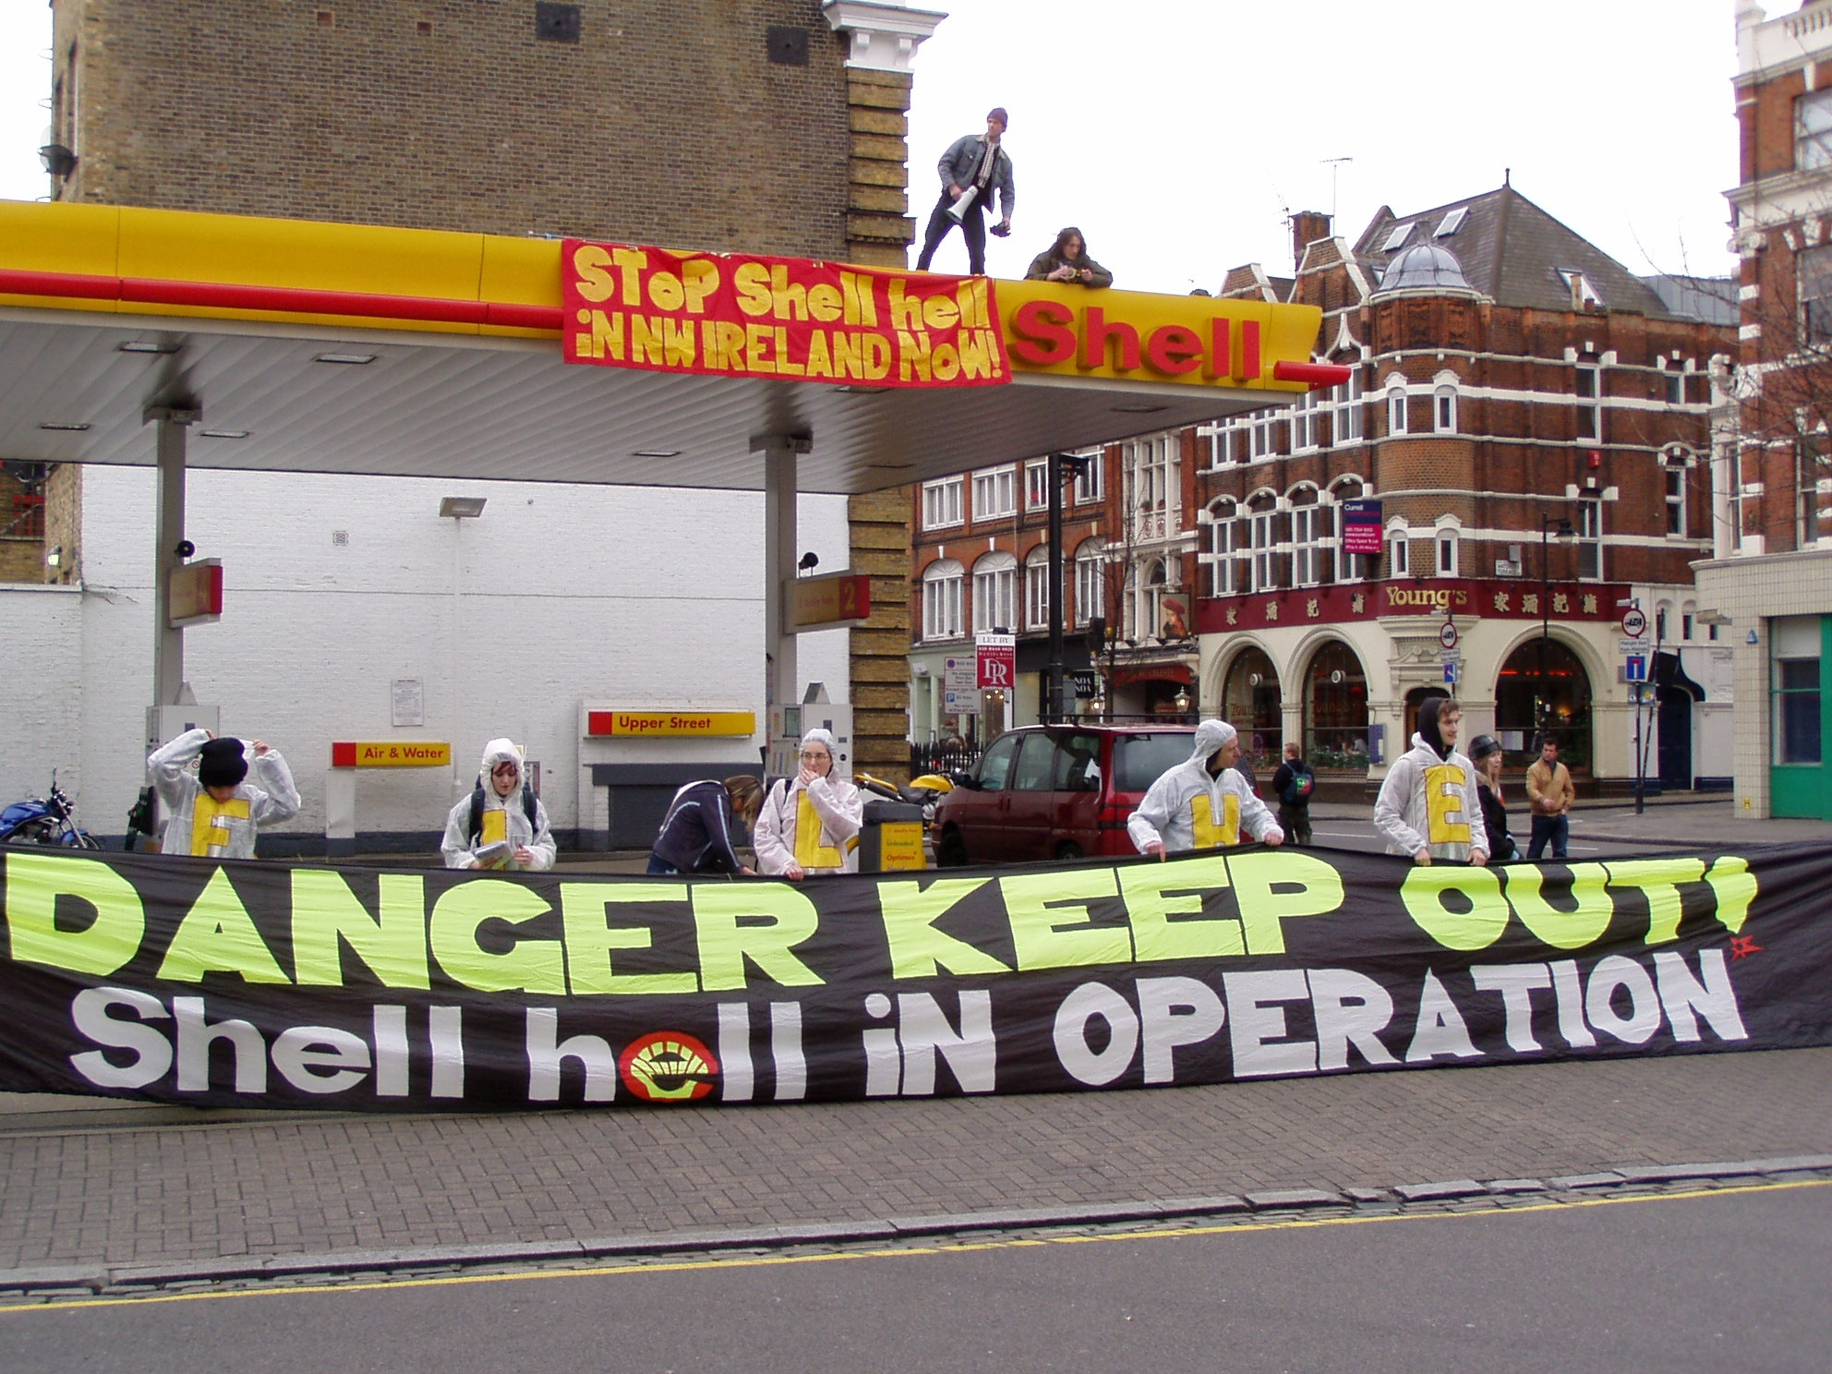

The way we chose to do it there are a few things that are needed:

1 – A ladder (high enough to reach the payment building/shop roof – from)
2 – One or ideally two people to climb the ladder onto the petrol station roof
3 – A banner for the roof
4 – Some banners for on the ground to block the entrances
5 – Some form of music to attract attention (live ideally)
6 – Leaflets to tell passers by and angry drivers why you are closing the station down (the leaflet we used is on the resource dvd in the leaflets section).

This is how we did it:

Everyone who was intending to come along on the day – to play music, hand out leaflets, hold banners etc… met at 1pm at a nearby tube station. Four people, the two who intended to go on the roof, a ladder holder and someone filming the event, also met at 1pm but nearer to the petrol station (the idea behind meeting separately was that if the larger group attracted unwanted attention from the police, the climbers could still get on to the roof and the action could still go ahead – which might not have happened if we had all met as one large group).

When they were ready, they calmly crossed over the road and walked to the side of the petrol station (it had been examined before to assess the best place for the ladder to go). The ladder was leant against the side of the garage (the shop bit where you pay – it’s usually not as high as the main forecourt roof) and the two people climbed up on to that roof. They pulled the ladder up after them and made their way across that roof and onto the roof of the forecourt itself (Test the stability of this bit before you walk out as it often usually doesn’t have much support below.).

At this point the ladder holder called the others using an action (clean) mobile phone to tell them it was now safe to arrive at the garage. Within minutes 25 people arrived at the garage. People holding the banner stood in front of the entrance to the garage with the banner stretched across to stop any more cars from driving in (dressed in white suits with Shell Hell spelled out on the front to draw attention and to look like a unified group).

Once all the cars had left, another banner was held across the exit to the garage. It was only at this stage that the workers inside the garage realised that there were people on their roof and called the police. The samba band moved onto the forecourt and began to play – something which bought a lot of attention from passers by, making it easier to hand out leaflets. If there is not a samba band in your area who wants to attend, then a small sound system or ghetto-blaster will attract attention.

On this occasion the police were very standoffish and didn’t bother us much for the hours we were there. They filmed the whole thing and had officers positioned nearby, but didn’t interact with us much. They did shut down the whole road at one stage, causing even more traffic chaos, which was useful from our point of view! However, when the two roof dwellers did decide to come down after about 4 hours, the police moved in and arrested them both on charges of suspected criminal damage to the roof. The two climbers were taken to the police station and held for a few hours, but the charges were later dropped – possibly as Shell did not want negative publicity and so wanted to avoid prosecutions.

At more recent petrol station closures (ones with just music and banners, no people on the roof) the police have been more ‘engaged’, threatening to arrest people if they did not move on. On some occasions people have chosen to move on but simply walked to another petrol station to repeat the performance (another group retreated to a cafe for an hour or so and returned to the same petrol station later on for a repeat!). The second time the police arrived however they were even more ‘engaged’ and people moved on relatively swiftly.

One note of caution is to say do be careful of angry drivers wanting to fill up. On several occasions people were nearly run down by motorists trying to drive through the banners.

