Greenwash Guerrillas Action

This is a tactic that a few Rising Tide groups have used at various oil industry sponsored events where greenwash is running high – Shell sponsoring this ‘sustainability’ event, BP sponsoring that arts event, etc. …

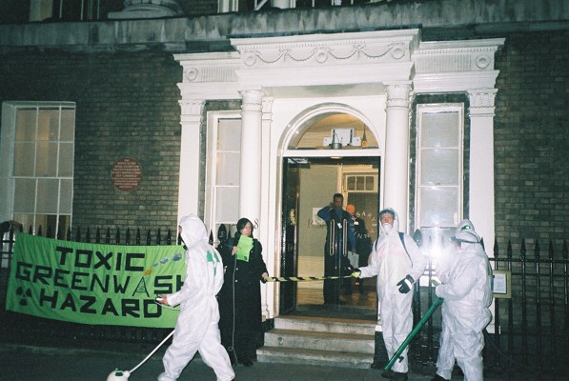

This action has three purposes:

- To inform the public that BP sponsoring the National Portrait Gallery, or whoever, is nothing more than corporate greenwash.
- To make these occasions less successful greenwash events - the high and mighty (who usually attend these events) being handed a leaflet on the way in means that they begin to question the motivation of the climate criminal – and possibly feel a bit dodgy themselves as they have to duck under the hazard tape, hopefully leading to them choosing not to support such events in the future!
- To persuade the sponsored event or institution that accepting money from oil and aviation companies or their like is no longer acceptable – effectively reducing their ‘social licence to operate’. This happened with the tobacco industry which used to sponsor events before that became socially unacceptable.

It’s really easy and good fun but you need a few props to start with:

1 – White paper suits (available in hardware stores quite cheaply) stencilled on the back with ‘Greenwash’ or some form of green radiation sign.
2 – Some highly sophisticated greenwash detecting equipment ;) – we made ours from some old hoover parts, a lamp, a broken hair dryer and a few green flashing bike lights.
3 – It’s great of you can get hold of some ‘cordoning off’ or hazard tape (green if possible) – that way you can cause more disruption by cordoning off the greenwash area or entrances to it.
4 – Leaflets explaining why the greenwash guerrillas are present – See our leaflet for some ideas (in the Leaflets section of the resource dvd).

Once you’ve got these props then it’s time to go. We tried to arrive well before the guest(s) of whatever event it was arrived, and meet somewhere nearby to prepare and get into costume (rather than at the location itself).

A note on the police – most times we did this action the police turned up, usually as we tried to walk into the building to start the event (promptly being evicted by the building’s security). The police often didn’t quite know what to do with us and so usually allowed us to hand out leaflets and enact out our little drama. On some occasions they asked us to cross the road away from the event, and sometimes tried to move us into a cordoned-off area that they had set up for us. We rejected their requests but it is up to you and your group to decide how far you want to push it with the police.

One last tip – have a practice before you set off. You don’t need to script it all but it is street theatre and benefits from a bit of preparation. Who is going to take on which roles – who hands out leaflets? Who will be examining the gutters to test for greenwash leaking out via the sewers? Who is going to cordon off the area? Should the people chatting to event-goers be in guerrilla character or would they be more approachable in normal dress? Maybe practice a few little conversations between Greenwash Guerrillas – to be shouted to each other across the area.

