Paint Blockade

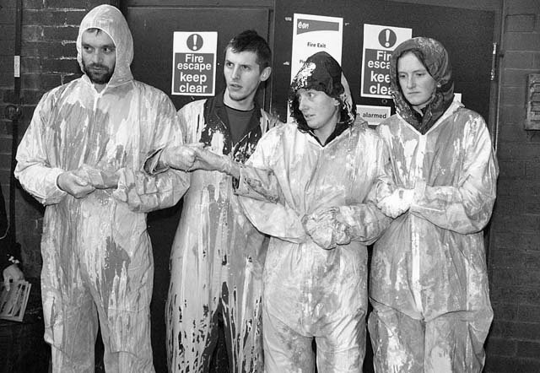
The basic premise
Paint / other sticky substances can be used as a blockading technique. The basic premise is that people will not want to touch you when you are covered in something that will ruin their clothes. It has worked on policemen and on office workers. Office workers do not want to ruin their suits. Police do not want their shiney vehicles / vans ruined!
It is particularly useful for blockading people out of offices, as it allows you to block doors without locking them, thus avoiding taking hostages and creating fire risks.

The basic technique:
- Cover self in paint and stand in the way.
- Linking arms / holding hands and creating physical barrier makes it more likely that they will get covered in paint if attempt to come past
- Having skin exposed will mean you get covered in the stuff, but means you are very slippery for people to hold on to.

Hints
- Clothing
- Wear overalls and old clothes. Be aware that paint will go through all your clothes, so don't wear clothes you don't want to be covered in paint!
- Wear old shoes – you will get your shoes covered too
- Wear rubber gloves to prevent getting paint on your hands

- Criminal damage: to avoid being arrested for criminal dammage, minimise paint contamination of surroundings by putting down a water proof tarp and standing on it to paint yourselves.
    - Tarps will flap in wind, so good to have something to weigh it down
    - Tarps can be very slippery once covered in paint – be careful!
    - You can also carry with you plastic foot coverings for when you walk away, and bin liners to put painted things in at end of action if you like.

- Paint:
    - We used up old emulsion that was watered down by about a 1/3. We made 2 littles per person, and put it in 1litre mineral water bottles with squirty tops. This was probably slightly too much, but allowed us to reapply liberally.
    - We coloured old white paint with food colouring to change its colour – be aware that this will stain your skin.
    - Black treacle has also been used to emulate oil and works similarly to paint.

- Applying paint
    - Do this on tarps to avoid being done for criminal dammage
    - We used squirty bottles to squirt the paint over our selves, and then smeared with our gloved hands. We had more than one person covered in paint so we helped each other get covered.
    - Pay attention particularly to sides of arms, legs and shoulders as this is where people are most likely to touch when pushing past you.

- Staying wet
    - Reapply paint often and use spray bottles with water in to keep paint wet.

- Getting away
    - Police seem reluctant to fill their vans full of painted people so hopefully you might get to walk away – someone with a change of clothes for you would be useful

- Support people
    - Support people will almost certainly end up with some paint on them and should laso wear old clothes.

