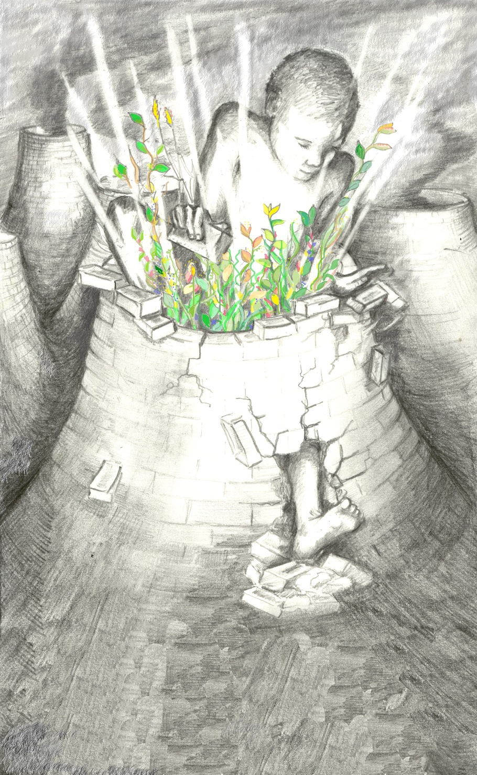
Direct Action
A Handbook
Contents of this handbook
1.Why take direct action | 3
2. Ideas for nonviolent direct action | 5
3. How to plan an action | 9
4. Affinity groups | 13
5.The buddy system | 15
6. Roles during actions | 16
7. Communication | 19
8. Quick decision-making on actions | 19
9. Personal safety on actions | 22
10. Medical issues | 23
11. Basic blockading techniques | 24
12. Preventing and de-escalalting violent situations | 34
13. Spotting trouble-police tactics | 35
14. Dealing with the police | 37
15. Security resources | 38
16. Action support | 39

Why take direct action?

It's empowering!
There's nothing else like taking back control of your life and standing up for what you believe in, in a simple but powerful way. Non-violent direct action (NVDA) is the single most empowering campaigning tool at your disposal. Don't take our word for it, try it and see for yourself.
It works!
NVDA is tried and tested in many countries and many campaigns. In recent years in the UK it's played a vital role in stopping the 1990s road building programme and ending the growing of GM crops, as just two of many examples.
Why non-violent?
For some people that's a tactical decision. Non-violence is more likely to win public sympathy for our cause than violence. And as the state is always able and prepared to use more violence than we can, it's tactically unsound to engage the state on a level where it will almost certainly win. For others it's a belief thing. Many people believe that if you want to build an ecological, peaceful and co-operative future you do it here and now by using ecological, peaceful and co-operative tools. NVDA is one of those tools. You don't get a non-violent world through violent means.
Why direct action?
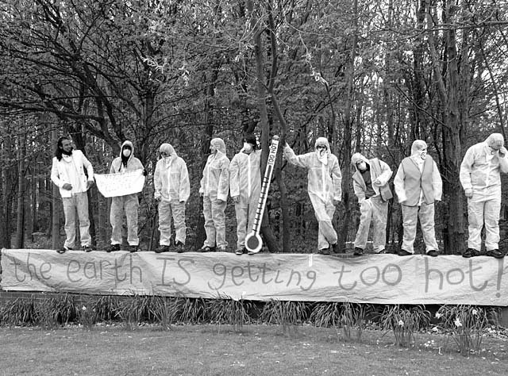
When was the last time you felt you really made a difference at the ballot box? So many people are feeling disenfranchised, feeling let down by our so-called 'democracy'. We watched Blair take us to war. We watched him approve a new generation of nuclear power stations and there's nothing we can do through traditional methods. Over a million of us march against the war, and still innocent Iraqis die. Apparently killing them was legal . NVDA gives you the chance to challenge and change that. Yes, it might mean breaking the law. But the law says war is fine. The law says nuclear power is fine, untaxed cheap flights are fine, GM crops are fine, Trident missiles are fine. And the same law says peaceful protest is no longer fine. If you're waiting for a legal solution to the world's problems, you better be able to hold your breath for a very, very long time. Do we have that long?
We live in a world that assumes we need leaders and laws to keep us in check; that we're incapable of making hard decisions and implementing them without being told how. Direct action is direct democracy. It's one way of challenging this myth and collectively re-asserting control over our destinies.
What about the consequences?
It's natural to be worried about the consequences of taking action. The power-that-be rely on it. They have us almost convinced that it's wrong. They provide other avenues for our frustration and desire to make change. If enough of us write to them, sign that e-petition, or of course vote at the next election they'll see what they can do. They make, but break manifesto commitments with impunity. There has to be another way. Think of the people that have shaped and are shaping our civilisation? I don't know about you, but my list is made up almost entirely of 'criminals'. Aung San Suu Kii, under house arrest in Burma; Mohandas Gandhi – criminal record as long as your arm; Martin Luther King Jnr., the Suffragettes, in and out of prison; the Dalai Lama in permanent exile because return to Tibet would mean imprisonment; not to mention friends being tried for attempting to disarm B52 bombers and save innocent lives. Behind each of these 'figureheads' are hundreds if not thousands of others just like you and me. They all broke (or are breaking, or will break) the law because they saw that the law was unjust. They recognised higher laws of conscience, compassion and co-operation. Were they really wrong?
Working together, taking collective, peaceful but dynamic action is no longer an option. It's an imperative. There's support on offer -workshops to help you explore what it feels like to take action, info on your legal rights. Take the support on offer and take action.

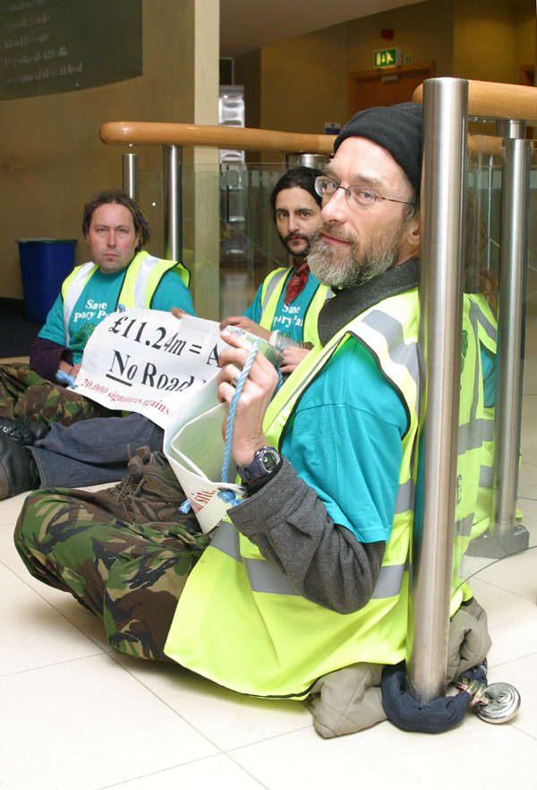
Ideas for Nonviolent Direct Action

Here are just a few of the techniques nonviolent activists have used over the years to make change. It's by no means exhaustive, and is in no particular order:

Office occupations
A classic 'disruption' action. Very simply put, activists enter a relevant building and occupy some area of it. Sometimes this is just the main doors or the foyer, other times it will involve getting further into the building and taking over a specific office. Activists have used office occupations as valuable information gathering exercises, taking the opportunity to explore filing cabinets and computer files. They're also an ideal opportunity to sit down and talk to staff.

Shareholder actions
Usually take place at a company's AGM. Share-owning activists (you only need to own 1 share) join with other shareholders and take the opportunity to ask the board awkward question, disrupt presentations by senior staff, hand out 'alternative' annual reports, and in some cases shut down the AGM altogether. This has been done by invading the stage, setting off fire alarms, removing plugs from the PA and AV equipment etc. Similar techniques have been used at conferences and trade fairs.

Blockades
Often take place at depots and corporate offices in order to stop deliveries or staff arriving at work. They may involve 'lock-ons', equipment that activists can use to lock themselves together to make it difficult for police and security to remove them. Blockades have also taken place at supermarkets, oil depots and military bases. They can involve anything from small numbers of people with relatively sophisticated equipment, or large numbers using the weight of bodies alone to block a road, gate or doorway.

Vehicle actions
Come in many forms. The most common are actions against convoys, such as those transporting nuclear material or other military hardware and stopping construction vehicles on building sites. Stopping vehicles requires good information (or patience!) and lots of thinking about safety issues, but makes a very public statement and can cost companies money.
Actions have also been taken against other transport networks. Examples include actions against trains carrying nuclear material in Germany, and UK activists stopping tube trains to prevent delegates getting to an international arms fair.
Flights have been targeted by anti-deportation activists,who board planes and then refuse to take their seats, preventing the flight taking off until they are removed from it. Runways have also been the target of anti-military, and anti-aviation campaigners, using blockading techniques (see above). Digger-diving is the name given to actions against construction machinery.

Banner drops
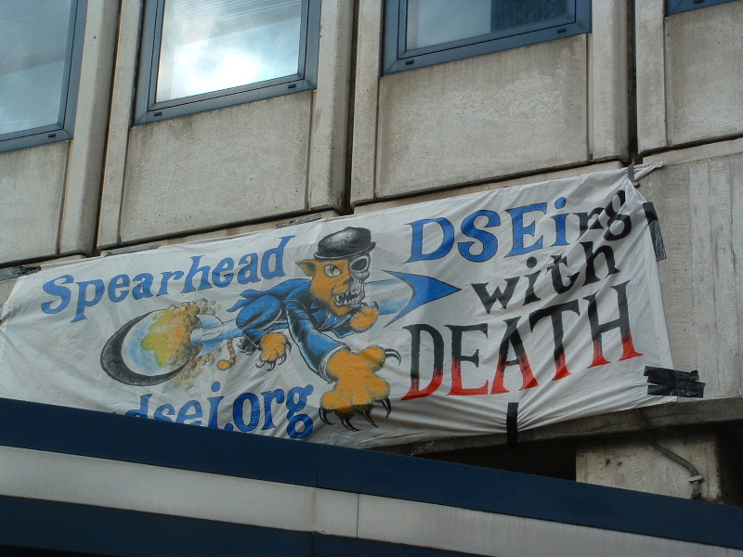
Banners have been hung from motorway bridges, Big Ben, power station cooling towers and many, many other places. The more inaccessible the place, the longer the message stays in place. Obviously some banner hangs require specialist climbers and aren't possible for all mere mortals. Other techniques have also been used – for example projecting a message onto the side of a building at night. There is also an auditory equivalent – blasting a building with sound equivalent to the aircraft noise suffered by resident living near airports, for instance.

Counter-recruitment actions
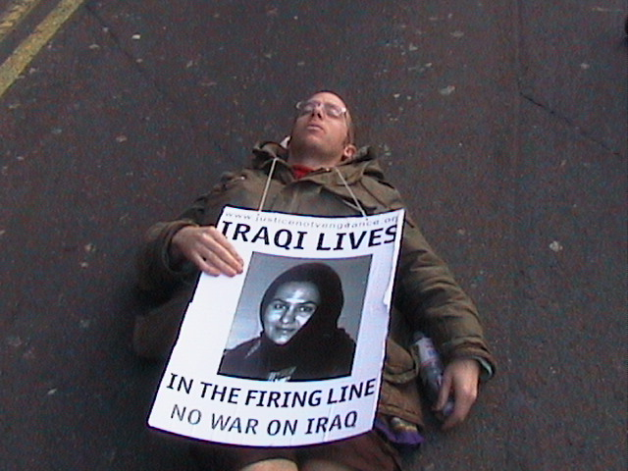
Have been used against the military and corporate recruitment events, especially on university campuses. These have included: pasting 'cancelled' signs over posters advertising the event; booking up all the places and then not turning up; attending the talk/stall and loudly asking awkward questions; setting up a spoof stalls or spoof event in the same building and giving the other side of the story; blockades and die-ins (see elsewhere).

Die-ins, sit-downs and sit-ins
Are all related actions that involve using our bodies to occupy a space in protest. Spaces occupied have included roads, university administration buildings, supermarkets, and steps to government offices. The die-in is a slight extension to the traditional sit-in. Activists protesting against arms trading, the nuclear industry or war have swathed themselves in bandages, liberally sprinkled fake blood, and lain down and 'died' in roads and buildings for long periods of time.

Ethical shoplifting
Involves removing unethical goods from the shelves of retailers and returning them to their rightful owners. Perhaps the best example is that of forest activists who have taken illegally logged tropical hardwood off DIY superstore shelves and handed it in to police stations, reporting the retailers for heir complicity in the illegal timber trade.


Subvertising
Takes the form of reclaiming advertising space and using it for our own messages. Common examples are stickers stuck over ads on the London Underground, or billboards that have had their advertising messages 'enhanced' or in some cases obliterated. Subvertising has been taken to new heights with the publication of spoof newspapers, conference programs & magazines that draw the unsuspecting reader in before delivering the environmental or social justice message.

Positive alternatives
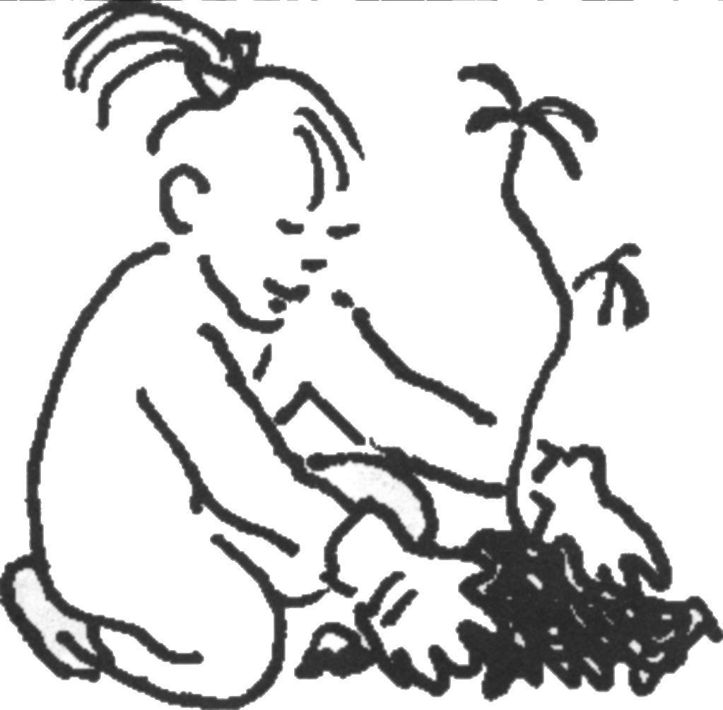
No discussion of NVDA would be complete without mention of those people that have taken action to create alternatives. Sometimes this has happened alongside campaigns of taking action 'against' something. Examples include activists handing out free veggie burgers outside McDonalds, setting up community gardens, creating their own road crossings outside schools, starting car-pools and so on. Often occupied spaces have been temporarily turned into art spaces or gardens.

How to Plan an Action
With a little thought, a good idea can be made into a great action.
Assess your time and resources.

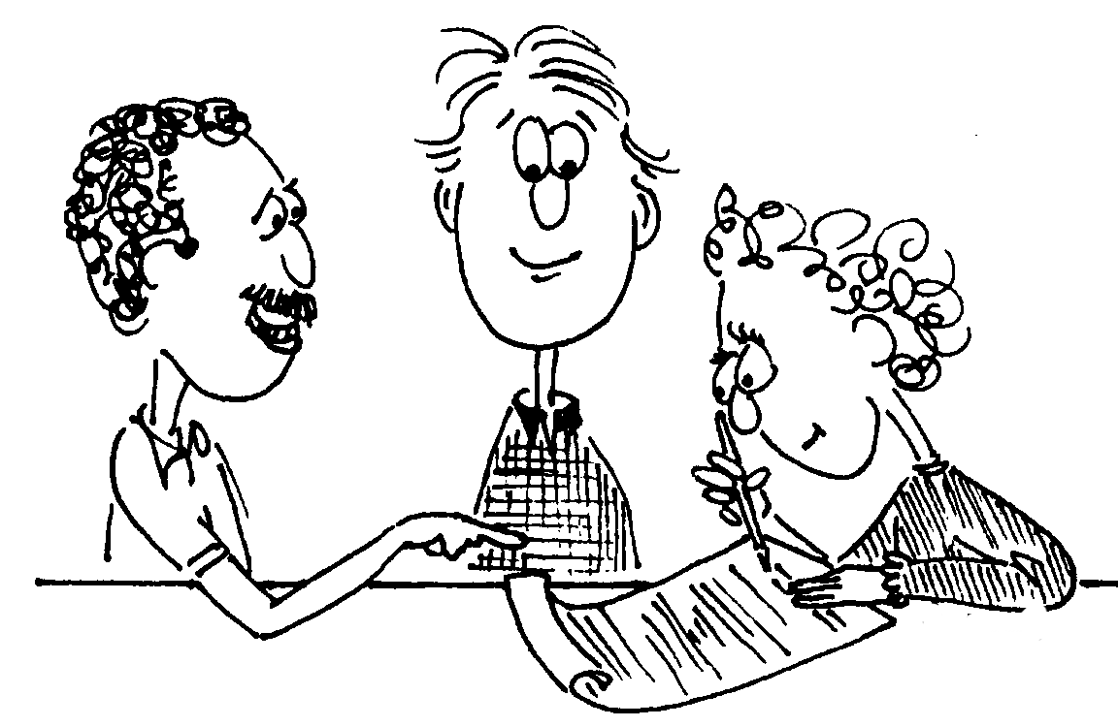
There's no point planning an event or action that you don't have the money, time, people, or energy for. Don't be put off by this - even small groups with only a little time and cash can make an enormous impact. It takes a bit of planning and organisation and some creativity, but it can be done.

Answer a few key questions:
- What is the message you want to get out? Be clear on this, because this will be the key factor in designing your action. Keep it simple and direct.
- Who do you want to hear that message? Are you aiming at a corporation or shoppers in the street? Do you want to seem reasonable to the people who meet you, or is the press coverage more important? Are you trying to get a photo in the press? Your message and method may well be different depending on the choices you make here. Is leafleting the employee of your local Esso franchise the best way to change Esso policy, or do you want to go straight to the top by buying a share and attending the company's Annual General Meeting?
- Is this a one-off action, or part of an ongoing campaign? The first needs to be focused and have a very clear message aimed at a very clear audience. The second needs to be strategic - you have more time to get your message across. If you’re planning a series of actions on the same campaign, you can change your audience each time. For example, as part of your campaign strategy, you might aim your first action at the public to raise awareness of the issue, a second at your MP as a form of lobbying, and a third direct to the offending company or central government.
- When is the best time to do this action? Is it a breaking news story? Is there a relevant local meeting or event? Can you coincide it with media deadlines or slow-news days? Is there any point doing an action at an office during the weekend?
- How many people can you realistically expect to turn out?
- How inclusive is this action? Is everyone in your group comfortable with the idea? If not, what are you doing to make those people feel like they still have an important role to play in the campaign and the group? Are you campaigning in other ways too? Direct actions & media stunts are just one way of winning campaigns.
Make your action match your message.
Actions are a bit like meetings - they can be welcoming and attractive or they can seem insular and aloof (even hostile). Be aware not only of what your message is, but how you are conveying it. It's a fact that people remember more of 'how' you say something than the actual words you use. The same applies to actions. Stick to a few clear points on your banners, placards and press releases!
Make sure the words you’re using match the tone of your action.
Preparing
Here's what we think you ought to take into account. You could appoint an overall action co-ordinator to act as a point of contact and to make sure it all happens, and then use this list to divide up tasks.
- Props and banners - what do you need, where will you get the materials & when will you make them?
- The law - know where you stand with the police or authorities if they are called.
- Research - get some handy facts and figures on your action, to be used in news releases, leaflets and briefings.
- Leaflet - you'll probably need to find or write one. Who are you aiming it at – you might write different text for a member of the public than you would for an employee of the company you’re targeting. Go back to your message!
- Media - You can increase the impact of your action by using the media. Send news releases, make sure there's a good photo opportunity, maybe appoint a media spokesperson. With the right visual image you can almost guarantee a photo in your local newspaper. Be creative!
- Publicity - make sure people who might be interested know about the action, and when and where to meet.
- Briefing - ensure that people on the action know what it's about - you could arrange a speaker meeting the week before, send a briefing by email, or meet in the pub beforehand to talk or read through it.

Action groundrules
If you’re organising an action, groundrules can ensure that it fulfils your vision of an effective action. If you’re participating, groundrules, or the lack of them, can help you choose which actions you feel comfortable taking part in.

Debriefing
Review the action afterwards, to learn from what went well and what could have been improved. Apply your learning to your next action! Do this as soon as possible, ideally on the same day.
- What happened to each person? How did people feel during the action? Was everyone supported by the group? How did the group interact?
- What was achieved? What could be improved?
- Does the group want to stay together for further actions?
- Do people need any continuing support, for example because they have a court case as a result of the action?

Celebrate what you’ve just done!
Take the time to socialise and congratulate yourselves. Actions need to be enjoyable if we’re to keep doing them.

Delegation & action planning
Any successful action relies on a group of people pulling together to make it happen. If the work falls on a few others can feel disempowered and the organisers can feel unsupported.
Democratic decision making is essential for good delegation. People will be much more likely to take on roles if they've had a hand in the decision-making of the group. It's much easier to ask someone to work on a project if it was partly their idea.
With the best will in the world, the same few people can't take on all the work of an active group and stay effective, even if they like being indispensable. Encourage new members to take on responsibility - share your skills and talents, even if at first it seems like it would be quicker to do it yourself. It will pay off in the longer term.
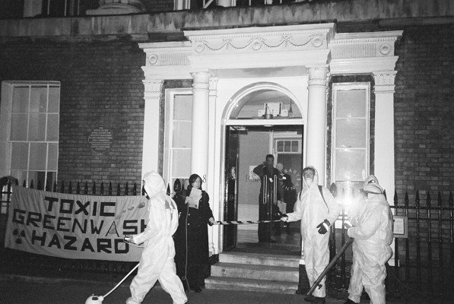
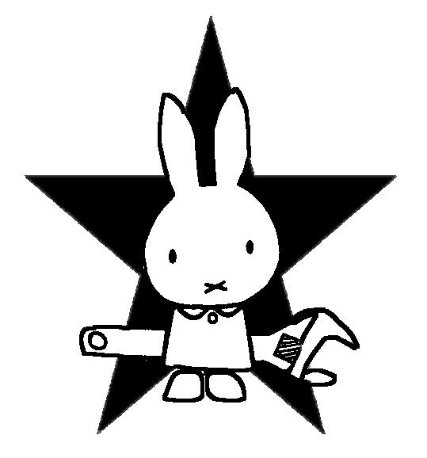
Affinity groups

These are small groups of people who prepare for and take action together. Affinity groups are organised in a non-hierarchical and self-sufficient way and can either act on their own or as an autonomous group within larger protests. Working in an affinity group is your best protection in the course of the action.
Roles and tasks can be split up between members, and you can support each other emotionally and in case of arrest or injury. A good size is 6-12 people. It's useful to form sub groups of 3-4 people who act as buddies.
Within the group share your hopes, fears, experiences, strengths and weaknesses. Agree on the form of the action in advance (how willing to risk arrest, the limits of your involvement, how non-violent, how spiky etc.)
Stick together - work as a team. Agree on a short name for your group which can easily be shouted and recognised, in case your group is split up and you get lost.

Working out a basic agreement
Each affinity group needs an agreement for how the group operates, how decisions are made, what it does and how it will react in certain situations. Everyone needs to be willing and able to keep to this agreement, even in stressful situations. It forms the basis for being able to rely on each other.
- Is this an open or closed group (i.e. can new people join the group?) How do we make decisions in the group? What do you expect from the affinity group?
- How do we react if... (e.g. the police intervene, someone gets violent)? How do we react towards people we encounter during actions (bystanders, the police, company directors)?
- How opportunistic is the group (e.g. what do we do if the plan was to hold up banners outside some office, but then there is the chance to actually get inside the building? How would that affect the group?) What happens if someone really feels the need to leave?
- A name for the group (for communicating on the action - e.g. shouting it to get everyone's attention)

Affinity groups on mass actions
Affinity groups can come together for mass actions and co-ordinate their activities via a spokescouncil. Each group sends a representative (often called a spoke) to the spokescouncil meeting, where issues such as tactics, overarching action guidelines and logistics are discussed. What the spoke is empowered to do is up to their affinity group. Spokes may need to consult with their group before discussing or agreeing on certain subjects. The spokescouncil does not take away the autonomy of each individual group – consensus on each proposal has to be achieved not only within each group but also among all groups together. During an action a spokescouncil can be convened to discuss immediate issues that arise out of unexpected situations.
Affinity groups can take on certain roles during a mass action, for example, there can be a legal support group, roving street medic groups, samba bands and groups providing food.
Affinity groups can also come together to form clusters that work on specific parts of an action. For example one cluster could occupy the office buildings while another cluster goes off to blockade machinery. In large blockades clusters can also take on an area.

The Buddy
System
Buddies are 2 or 3 people who stick together and look after each other throughout an action. Being a buddy means you never leave your partner(s) - ensuring no one gets forgotten.

Buddies:

- know if their buddy has any special (e.g. medical) needs
- keep checking that their buddy is still with them
- make sure that their buddy is physically ok and find food/drink/warm clothing/medical attention if they aren't
- leave with their buddy if they want to go, for any reason
- keep an eye on their buddies emotional state and try to calm them down/comfort them when necessary
- tell legal support if their buddy gets arrested.
- call for observers/first aiders if their buddy is injured.

Roles During Actions
Many tasks and roles need to be taken on during an action.
Sit down with your affinity group and draw up a list of all the tasks and roles that need covering and decide who will do what. It's vital that people have a clear understanding of what their role involves. They also need to stick to their role throughout the action, and not just wander off in search of a cup of tea. Roles will vary from action to action, and sometimes people take on more than one role. Sometimes people can take on more than one role, e.g. a legal observer might also be a first-aider, or police liaison, or even media contact.
Transport:
Self-explanatory, really - many actions need vehicles, and vehicles need drivers and map-readers. In most cases drivers will need to avoid arrest, so they can drive people home as well.
Police Station Support:
Stays somewhere safe and away from the action, next to a phone. They should have all pertinent information about each member of the group such as their name, if they want someone contacting if they're arrested, and if so who, etc. They take calls from the police station and from legal observers, and co-ordinate post-arrest support, which might involve tracking down anyone who was arrested, ensuring that a solicitor knows they're in custody, and picking people up from police stations on their release. They should have access to transport to reach all the police stations in the area, and know how to get to them. They might take snacks, cigarettes, water - whatever people will want when they are released.
First Aider / Street Medic:
The more people who know medical care of any kind the better, but in many types of action it is wise to have at least one person who knows basic first aid. For a large mobilisation, street medics should also know how to deal with the effects of CS gas.
Legal Observers
take notes on police conduct, arrests, violations of activists' rights
Police Liaison facilitates communication between police and affinity group



First Aiders deal with any medical or health issues
Action Support provides direct personal support for action participants (food, water etc)
Roles
on Actions

Legal Support
(at the end of a phone) keeps track of arrests, works with solicitors
Traffic Wardens responsible for the safety of people from cars and other vehicles

Transport drivers with cars/buses

Media Liaison
empowered to talk to the media and act as a spokesperson

Quick Decision Facilitator
helps group to make decisions quickly
Legal Observer:
Stays on the fringes of the action and is responsible for responding to calls from those taking part in the action if the police are being unreasonable or are making arrests. They should take detailed notes of interactions with police including names of anyone arrested, police badge numbers, what took place and exactly when. They can also help police station support people by finding out which police station arrested activists are being taken to, and what charge they've been arrested on. A camera or video recorder can be helpful. Being a legal observer is no guarantee of immunity from arrest.
Police Liaison:
Conveys information and demands between the police and the group. Ideally your police liason will be articulate, calm, and able to communicate diplomatically with the police. They can try to de-escalate the situation as much as possible to avoid police over-reaction. It's important that the group give the police liaison a clear mandate. Are they empowered to take decisions for the group? In most cases they are not the group's decision maker, and it helps to communicate this clearly to the police early on. They can facilitate the decision making process though (and slow down the police response) by acting as a go-between and consulting all activists, then reporting back the decision to the police. Like observers, they aren't immune from arrest!
Media Liaison / Spokesperson:
Helps facilitate the interactions between the group and the media. They prepare news releases and make calls to get the desired media on site at the time of the action. They should know the issues and be able to speak clearly and articulately to reporters and TV cameras. Media work is often split into two distinct roles – background media work (writing and sending news releases) and the spokesperson on site.
Action support:
Provides direct personal support for arrestable people. This person may risk arrest, but tries to avoid it. Depending on the nature of the action this means bringing water and food supplies to action participants and keeping everyone high-spirited and informed. Activists may be scattered over a wide area, and action support is vital in keeping them in touch with the overall progress of the action. They might also be needed to carry messages and facilitate group decision making. For actions involving lock-ons it is best to have at least one support for every two people risking arrest.

Action Participants:
Quite simply the people carrying out the actual action (climbing, locking on, sitting down etc). Should be technically prepared for everything they plan to do, and well rested, fed and calm. Last on this list for good reason – they are only able to play at being ‘direct action heroes’ thanks to all the support team’s hard work.
When you're working with others, you need to think about communication. How will you stay in touch? Can you assume that in large crowd or in the dark of the night you'll be able to stay withing sight and sound of each other? It's worth thinking through and agreeing a few strategies in advance.
Communication
Mobile phones can be risky. You may not hear them ring and you may not have reception.You could use whistles, but how will you distinguish your whistles from those of the rest of the crowd? You could have a visual signal to regroup and talk – a hand signal, or a distinctive flag.
It's definitely worth having an agreed meeting place that your whole group can fall back to if you get split up or if the protest becomes more 'full on' than you're comfortable with. If you agree such a place everyone needs to know how to find it, and it needs to be a space that will stay safe throughout the day.

Knowing where you are
Knowing your way round the site of any action can help you stay one step ahead of the police, find secure places to rest and recover, or stay mobile and allow you to take effective action. It's worth getting hold of maps and street plans of the area and making sure everyone in your group has at least a basic understanding of the geography.

Quick Decision-making on actions
Actions are fast moving situations and rarely go as planned. Your affinity group will have to make quick decisions on how to react to changing situations. Taking decisions by consensus ensures that everyone is behind the action. Consensus doesn't mean that everybody always agrees, but that everybody supports the decision.
Since consensus needs everyone to agree to abide by the process, and to be familiar with it, you need to be honest with yourselves. Sometimes it might be better to bite the bullet and appoint someone to take decisions in a tight corner (you can, of course, agree this in advance by consensus!).
Before the action work out what people are prepared to do and what limits they have (eg not willing to risk arrest). When faced with such a situation in reality you've got some idea of what the group might want to do. It's best to have a few practice runs in your group. Give yourselves 2min to come to a decision on scenarios (eg. “You're taking part in a march. The police have given you 2 minutes to get out of the road, or they'll arrest you all. What do you do?”)

Outline of quick consensus:
1)Appoint a facilitator in advance!
2)The facilitator briefly states the situation to make sure everyone is clear:
“ We’ve been given 2 minutes to move or we'll all be arrested”
3)The facilitator asks for proposals: “Any proposals?”. In some cases there may be time for discussion, but in others there won’t be. It’s up to the facilitator to assess the time and act appropriately…
- Someone makes a proposal
“Yeah, I propose we link arms and sit down”.
In some cases you might have time to make friendly amendments to the proposal.
5) Facilitator restates the proposal, for clarity, and then tests for consensus:
“OK, it's proposed that we sit in the road and link arms. Any Blocks?” – “No”
“Any Stand asides?” – “Yeah, I’ll lose my job”

A Block kills a proposal - it's a total veto.
Everyone has the right to block. In quick consensus people normally block for 2 reasons - 1) a proposal will split the group or 2) the group is failing to make a decision. If a proposal is blocked, you need a new one! Some groups insist that in quick consensus you must have a counter proposal before you can block.
A stand aside is agreeing to disagree.
It allows the proposal to go ahead in the group's name, but those that choose to stand aside take no part in that action.
A friendly amendment enhances a proposal.
It's not a new idea, but a way of making an existing one more effective.
Groundrules
- Active agreement – consciously participating in the decision, and showing agreement (using handsignals or whatever) – if you're not getting active agreement, you need to ask “is there really any energy for this idea?”
- One voice at a time – avoids discussion descending into chaos. Handsignals can help structure this
- Handsignals: there are a number of hand gestures that can speed up the process of decision making. For them to be effective, everyone in the group must be fluent with them, so agree them in advance! You might want to minimise the number of handsignals you use – do you have time for 'Technical Points' or 'Process Points' or any of the many other handsignals in common use in activist circles? The essential few seem to be:
- 1 finger raised - “I'd like to speak”
- 2 fingers raised - “I've got something immediately relevant to say”
- Hands waving with fingers upwards (someitmes called 'silent applause' or 'twinkling') –“I support the idea currently being discussed”, “I agree”
- Fist - “I block this proposal”

Personal Safety on Actions

A hat or hoody and sunglasses protect not only from the sun but also from intrusive intelligence gathering by the police.
Several thin layers, long trousers plus raingear. You can always take them off if it's too hot or if contaminated with CS gas. Thin long sleeved shirts protect against sunburn.

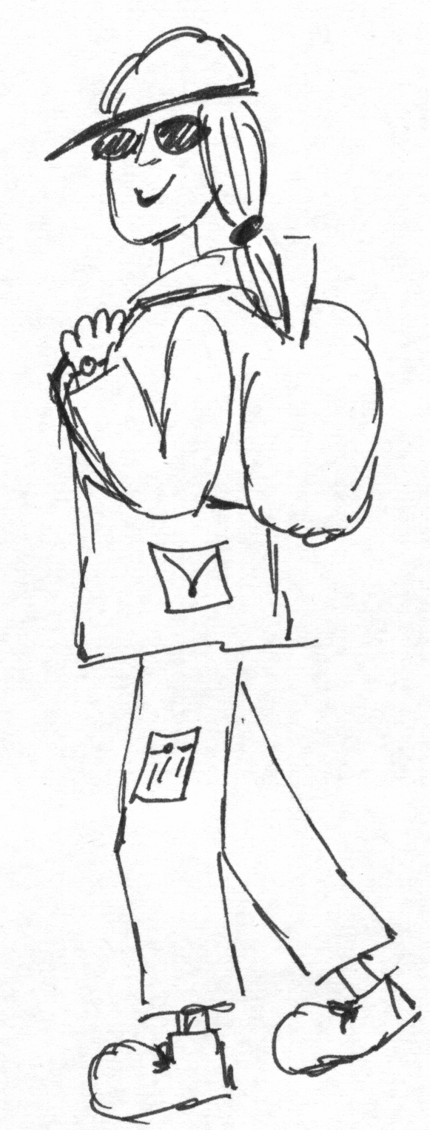

Remove jewellery, tie up hair and cut nails - helps to avoid getting hurt. Hair can get tangled up and offers a nice handhold for police.
A watch – synchronised with those of your mates.

Pockets with zips and rucksack for putting essentials into.

Supplies - plenty of water and food; bust cards (telling you your rights on arrest and solicitors number); change for phone, bus or taxi fare; tampons; toilet roll; midge repellent.
Sturdy boots to protect your feet (even on a hot day!)

Do not take:
“Offensive weapons” (anything pointy or heavy eg penknives/ screwdrivers); illegal drugs; alcohol (impairs your judgement), credit cards, ID (unless you're from a foreign country or driving a car), address books/diaries – the cops would love to have your mates' phone numbers. Mobile phones: can be useful but get a clean simcard (the little chip where all the info is stored). briefing sheets, maps etc. If you’re arrested the police will search you and can use anything they find as evidence against you or other activists.

Delia says: “Always empty your bags and pockets before you leave. Only take what's really necessary.”

Medical Issues
ALWAYS carry water and food for yourself. Drink lots of water to avoid getting dehydrated. Carry water in cycling type water bottles (the ones that are squeezy with pop up tops) as these can be used for eye flushes to treat CS gas. Eat regularly to avoid your blood sugar getting low, which makes you disorientated and a danger to yourself and others. Take emergency sugar rations eg.chocolate, flap jacks.
TELL your mates if you have any medical issues (eg asthma, epilepsy, diabetes, pregnancy, heart problems etc.) Carry any emergency medication you might need, eg insulin, inhaler, even if you have not had a problem for a long time. Also take your prescription (otherwise the cops might take it off you). Wear a small wristband with medical issues written on it to makes it easier for medics to treat you.

On mass actions TEAR GAS may be used by the police to make people panic and to disperse crowds. Most importantly - Stay calm!
- Wear well-fitting swimming goggles with shatter proof lenses to protect your eyes. Prescription swimming goggles are available. Carry vinegar/ lemon juice soaked bandanas in sealable plastic bags - effective for short periods against breathing CS gas.
- Make up, sunscreen or midge repellent needs to be water or alcohol based rather than oil based. Tear gas is soluble in fat so creams make it worse and may cause burns.
- Bring spare contact lenses / glasses. If exposed to CS gas or pepper spray get contact lenses out quickly as the gas can get trapped behind the lenses and burn your eyes.
- Get rid of any contaminated clothes and flush out eyes with cold water. The burning will subside eventually.
Make sure you have a first aid kit and someone with first aid skills in your group
UK Action Medics provide first aid training for actions www.actionmedics.org.uk

Basic Blockading Techniques

The aim of all the techniques mentioned below is to increase the length of time that you can remain at the site of an action and therefore hopefully increase the effectiveness of your protest, whether you are blocking the entrance to a power station, stopping oil tankers or preventing trees being cut down.

Using your body

If you have nothing else to hand then the best thing you have is your own body weight. Sitting or lying down makes it much more difficult for security guards or police to push or move you away from the place where you want to be. You can increase this difficulty by passively resisting (see below).
Co-operating with others can further increase your effectiveness:

Linking arms
Sit close together and link arms with your neighbours. The more of you that can link arms the better. Five or more people can block a single carriageway of a road. More than a dozen and you can block both carriageways! Link arms at the elbow and bring your hands in front of you. Take a tight hold of your own wrists or elbows. You are now a bit harder to move - the police will need to break your grip before they can pick you up and carry you away. If you're linked together in a line, the people at the end are more vulnerable, so you might want to consider sitting in a circle.
Linking arms and legs in a circle
Five or more people can form a circle then link arms as above. If everyone's facing inwards, the circle can be made more impregnable by jumbling up your legs as well. If your facing inwards you won't be able to see what's happening behind you. Work together with your group and act as each other's eyes and ears.

Passive resistance
Passive resistance is an age old protest technique used to slow down your removal from a protest once you have been arrested. To some people it's an ideological statement about not co-operating with the authorities.
Essentially you simply relax your muscles so that you go limp. Best to do this when you're already sitting or lying, though you can passively resist from standing if you're willing to take a fall! By totally relaxing you make it much more difficult for the police to get a good grip of you and to carry you. Instead of being walked away by one officer, you will now have to be carried which will take several officers. Depending on how many police are at the action this will slow down the removal of you and your group considerably and they may even give up when they get tired, or if its too far to the police van. Relaxed muscles also hurt less when they get banged and bumped.
Be aware of the difference between passively and actively resisting arrest. If you flail your arms and try to wriggle away or try to release their grip on you, you may face a charge of 'obstructing a police officer in the execution of their duty'.
Remember, it’s always your choice, so if it gets uncomfortable when they start to carry or drag you, you can get up and walk at any time. Wear old shoes and clothing that won't ride up when you are being carried. A rucksack can help protect your back. Some people advise that you break the rule about total relaxation, and keep your chin tucked tightly forward to stop your head dangling and possibly being damaged.

A word on communication
It's easy to get carried away and start shouting at police to let your compadres go, especially when friends are under pressure and possibly in pain. Remember that you need to be able to communicate with each other. Maybe the person being pulled out of your line or circle doesn't want you to hang on to their leg and play tug of war with the police, using them as the rope. You need to be able to hear them and respond if they ask for support, or ask you to let go. Keep communication calm and clear and talk through likely scenarios and personal limits in advance, if possible.

The tools of the trade
(Borrowing heavily from 'Road Raging': www.eco-action.org/rr/ch12.html)
Banners
The most basic blockading prop is a banner – there's usually one around somewhere. Wrap your circle up tight in your banner to make it harder for police and security to break you apart. If the banners made of a tough material so much the better. If you've thought in advance to stitch in a few loops of nylon webbing (old seatbelt or rucksack straps) through which you can stick hads and feet all well and good......

Seatbelt lock-ons
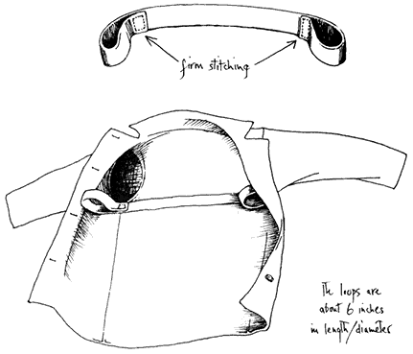
These are effective, low tech and cheap. They work by you wrapping your arms around something e.g. a tree or a vehicle axle, and then putting your wrists through loops sewn into your coat lining, under your armpits - right wrist to left armpit and vice versa. Alternatively you can work with others and form lines or circles by placing your arms round each other and through each others loops. Coat loop lock-ons are inconspicuous and mean you are always ready for action! Sew about a metre of strong, tough material - old seat belts (available from scrapyards) or climbing tape - into your coat horizontally across the shoulder blades up to the armholes. Then double back the excess and sew the ends very firmly into place to form loops. The bigger the loops, the easier they are to find in a panicky situation. The smaller they are, the harder it is for them to pull your hands out (although you can twist the loops round and round so they tighten around your wrists). Practice with them, especially if planning to work with others.
The tape goes around your shoulder blades directing the pressure around your back rather than on the coat. The loops are very difficult to get to, being under your garments and under your armpits. They may rip or cut your coat to get to them, so use an old coat. You can design them to be worn as a 'waistcoat' without stitching them into a coat. If you're having to go through airport style security, and can't get any metal items in, seatbelt lock-ons are a lot better than nothing!

Handcuffs
Handcuffs are good for carrying in your pocket unobtrusively and for locking on underneath machinery, to gates etc, but are easy to cut off - most handcuffs are pretty flimsy. Loops of strong cord or tape can often be just as effective and are cheaper. Decent handcuffs are difficult to find. Army surplus or "sex shops" sometimes sell weak ones. Most handcuffs can be undone with a standard key type, which security, police and bailiffs often carry. They also have a 'self release' catch that you need to saw or snap off before you use them.

Super glue
Ah, yes. Who'd have thought that a little bottle of the stuff can be so effective. You can superglue your hands to doors, windows or any other surface around. Or you could glue your hands together, around an obstacle of course. Make staff, security guards and police aware that you're glued on and that pulling would seriously hurt you. The only way to get you off is a bowl of soapy water, some acetone and a lot of patience...

Padlocks
Padlocks and chains can be put on gates cause confusion and may hold up work, while they run around looking for the keys and then bolt croppers. Superglue or liquid metal in their padlocks means that they have to cut off their own locks and keep buying new ones.

D-Locks
Bicycle D-locks are a classic direct action tool. They fit neatly around pieces of machinery, gates and your neck. It is worth working in pairs when trying to lock on. The person locking on carries the U shaped section, and loops it around both a suitable fixed piece of machine/gate and their neck. Then their "buddy", carrying lock barrel and key, secures the lock, and hides, or runs off with the key. If locking on to a machine, someone must let the driver know that operating it will break someone's neck. If locking on, you may be there for some time, so choose your point carefully. They may remove any blankets or seats you have, and isolate you from other protesters, sometimes forming a screen around you.
You may want to keep a spare key about your person but they may search you for it. Any search should be conducted by a same sex officer. If the buddy stays (with key) within earshot, then you can be released in an emergency. It is important that anything you lock onto cannot be removed or unscrewed (like a vehicle foot plate or bumper). Gates can sometimes be removed from their hinges, so consider securing the hinge side as well as the opening side. If there isn't an immoveable object then D-lock yourselves together around the neck in pairs or groups and sit in the road.
If the police are not expecting you they won’t have the appropriate cutting equipment available immediately and so you might be able to stay there for an hour or so until they come with boltcroppers. Most contractors have their own hydraulic boltcroppers, which cut the strongest lock in seconds. The lock gives a frightening jolt when cut, so don't lock on if you have a neck injury. Locks are most effective on targets remote from croppers.

Vehicle lock-ons
If you are locking on under a vehicle you will need several support people to communicate directly with the driver to tell them you are under the lorry and that they will kill or injure you if they try to move it. They should try to get the driver to switch the engine off. Until it's absolutely clear the vehicle's not going anywhere, it's probably best to have one or two people standing in front of the lorry to stop it moving, carrying a big 'Stop!' sign. Parking a vehicle in front of the lorry is even more effective as the lorry driver is unlikely to try to drive off into a vehicle, but they have been known to drive through a line of protestors. For more on safety see Delia's Guide www.geneticsaction.org.uk/delia.pdf.

Arm tubes
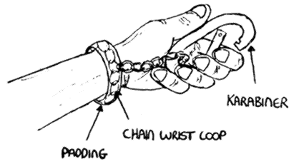
Arm tubes are best made from thick metal pipe such as old cast iron drainpipes or lampost shafts (ask at your local scrapyard), but can also be made from plastic pipe or even cardboard. Your tube needs to be the diameter of a clothed arm and three to four feet long. Ideally the tube should have a strong metal pin welded across the the middle. It can slow down the process of cutting you out of a tube if you hide the welds with paint. You also need to make a loop of strong cord, chain or climbing tape which fits around your wrist and attaches to a climbing carabiner or spring clip (cheaper and available from most hardware stores). When you put your arm in the tube, clip the carabiner over the centre pin. If you're using a tube without a pin, you'll need to clip on to your partners carabiner. Remember that if you lock-on with handcuffs, you won't be able to release yourself. Check before the action how many layers of clothing you need to wear to get a snug but not too tight fit in the armtube.
Arm tubes can be used in lots of ways: as a chain across a road or entrance; as a big circle in the road or around machinery; two people can use armtubes to lock themselves around part of a vehicle chassis or around the wheel of a lorry; or one peson can use a shorter tube or a 'V' shaped tube to wrap themselves around a digger arm, vehicle prop-shaft or a post. Depending on the configuration of the entrance/road you want to block, you might also want to consider using 'Y' shaped tubes for securing a chain of arm tubes to immovable objects, like lamp posts, at either side of the road.
The police or baliffs will try to remove you if they can without actually cutting through the arm tubes. They sometimes try to push a hooked blade on a pole down the tube, to cut any cord or tape attaching you to the tube. Having a tight fit with your clothing or padding the arm-tube with foam, fabric etc, can hinder this, as can using chain instead of fabric to attach your clip to your wrist. They also sometimes use fibre-optic cameras to try to see what your arm is attached with, but its easy to obscure the probe with your hand.
They may use threats and intimidation or inflict pain using pressure points or twisting your arm until you unlock yourself or they may use the 'lets wait until one of them needs a pee' strategy. The answer to that of course is not to drink too much before hand and to wear incontinence pants!
If they can't persuade you to get out of the lock-on then they will probably use an angle grinder to cut the tube near the pin until there is a hole large enough to get in to cut the tape or chain or to unclip the carabiner. Once one tube is cut then the whole line or circle is broken.

Staying comfortable
It can get cold sitting or lying on the groud so dress for the weather and stuff bin liners and pieces of roll mat down the back of your trousers. Take lots of snacks and drinks but remember to have some support people who can feed you if you have both arms in tubes! Be aware that your support people may be moved away or even arrested. Lock-on at the last practicable moment as it can be uncomfortable, and go to the loo first!
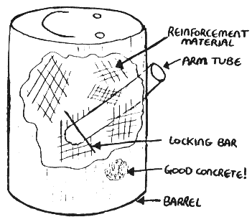
Concrete Lock-ons
Concrete lock-ons or 'dragons' can be built in houses, up trees, at the base of trees, in oil barrels, washing machines, roads, in cars and in tunnels. They are constructed from an arm tube, with a metal crossbar at the bottom, which is then set in concrete. The concrete mix is: 1 part cement to 3 parts sandy aggregate, it can be strengthened using washing up liquid. Pieces of chopped-up tyres and metal mesh, knuts and bolt, bits of scrap metal can be added to the concrete mix to hinder drilling out the concrete. The concrete needs time to set to its full strength so make them well in advance. When building, plan it so that the person will be in a comfortable position as they could be there for some time. To lock-on, put your arm down the arm-tube and clip your arm to the cross bar (see Arm tubes).
If they can't get your arm out, they will probably use a combination of power tools angle to cut through any outer barrel or other metal coating and get through the concrete. They will then need to cut through the arm tube, again using an angle-grinder. This will take quite a while, and will be noisy, dusty and scary. Have goggles, ear plugs and a dust mask with you.
Other lock ons have been built by welding metal arm tubes together in X or H formations to accommodate 4-6 people and slows down the cutting team considerably because it makes the lock-on too heavy to move and they will need to cut through more than one armtube before they can pick you up and move you all from the road. You could weld a very heavy object to your lock-on to make it even harder to move - cattle-grids, steel plates, lorry wheels and dead cars have all been used, making it difficult to cut through the tubes and difficult to simply lift you out of the way.
All the advice about support, confort and safety from the Arm tube section applies to lock-ons.

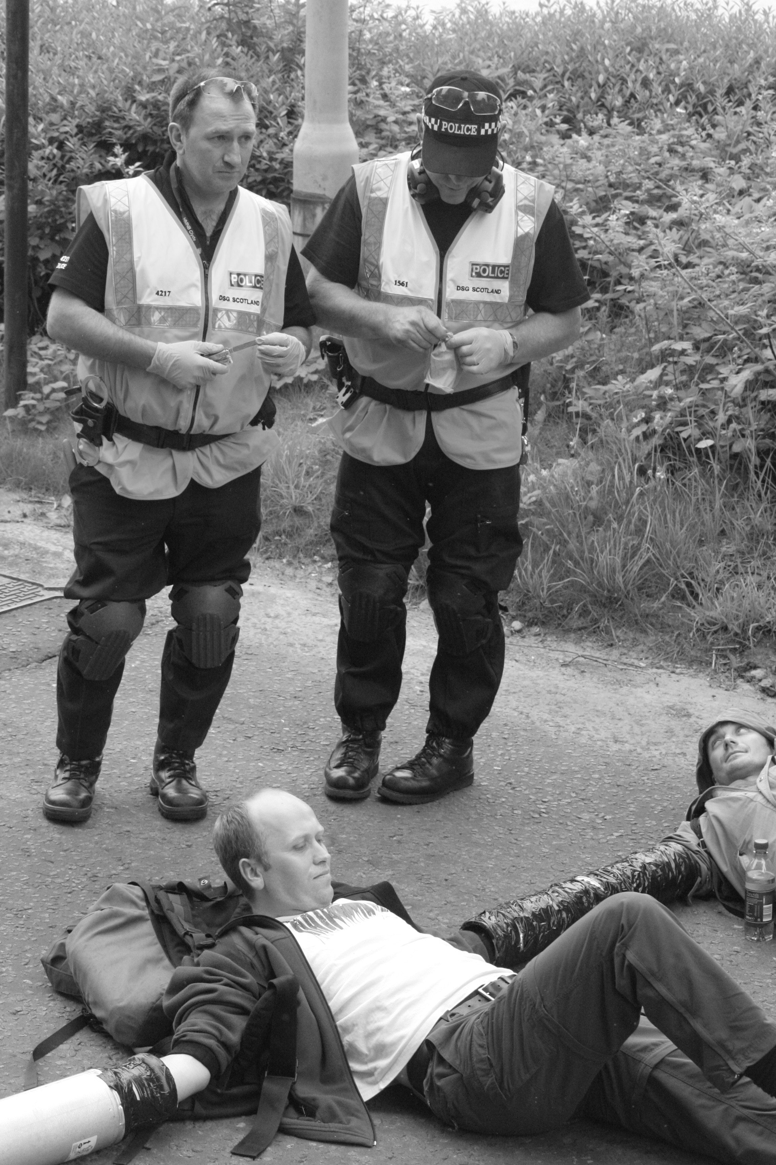
Disposable cars
You can buy scrap cars very cheaply, but you will get arrested if you're stopped while driving an unroadworthy, uninsured, untaxed car. You can use cars to blockade gates, roads, motorways - just about anything. You can immobilise the car by slashing the tyres, removing wheels, or turning it over. You could also try building concrete lock-ons into the car, welding armtubes to the chassis or simply using D-locks to lock on to your own vehicle!

Safety and comfort
You need people to ensure vehicles aren't moved when you're locked on and help mediate if you're facing aggression, as well as people to keep you fed, watered and to light your fags when you've got both arms in arm tubes. It might be worth having someone to liaise with the police to ensure they fully understand the safety implications of your action.

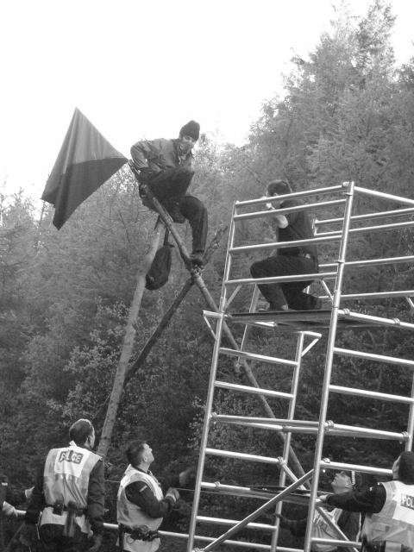
Communication and decision making
If you're locked on under a vehicle, or in an inward facing circle you won't know for sure what's going on around you. You might be blocking the rear gate of a compound and have no idea whether the activists at the front gate are still in place. Having someone to roam from lock-on to lock-on, person to person, and keep everyone up to date with what's happening is vital. They can also facilitate decision making for the group as a whole.
Other roles
If you plan to use the media, you may need to ask someone to be the face and voice of your action. The police are unlikely to let cameras get too close to locked on activists, so you may never get the chance to say your well prepared piece.
You may also want observers to help reduce the risk of aggression and to record any arrests and ensure arrested activists get support at the police station.
Remember support people 'on the ground' are not immune from arrest. It's quite likely that at some stage they'll all be asked (or more likely, told) to move away from the site of the action. Since they can't offer effective support from the back of a police transit van, they may need to negotiate – another role for the 'police liaison' person?

Preventing and de-escalating

violent situations

Quite often we're faced with aggression on actions – from employees, the police, passers-by and sometimes fellow protesters. Or you yourself might “loose it”, eg when you see a friend being hurt. Being aware of what can lead to aggression and violence on actions can help to avoid these situations arising, and keep the action safe.
Stay focussed on your aims - Work out what it is you want to achieve and how you will do this. A clear motivation and sense of purpose can help you to stay focussed in a chaotic, frightening situation.
Work in affinity groups. This not only provides back-up but also support when a member of the group starts to get stressed.
Stay calm, relaxed and alert. Try to notice things before they become a problem so that you can respond in good time. If you're scared or feel your adrenalin pumping, take some deep slow breaths into your stomach – this will calm you and allow you to think more clearly.
Create a positive atmosphere for yourself and others. Make music, sing and laugh. Share hot tea and chocolate around.
Think of the opponent as a human being. Show respect. Be aware of their capacity for positive action. They may also be worried or afraid. Treating others in a way that you would like to be treated.
Watch body language – your own and others. Look relaxed and open, use gentle hand movements - avoid sudden moves which could be interpreted as hitting out. Don’t make fists. Use non-threatening eye contact. Avoid getting into people’s personal space.
Don’t act submissive or frightened. Don’t plead and beg, don’t fold arms or look away. At the same time don’t be aggressive, threatening or insulting. Physical violence may make an attacker feel justified.
Watch your language. Say “I”, ask questions. Keep your voice low but clear and under control. Be relaxed, but firm. Do not rush into faster and faster speech. Only interrupt if people are being personally abusive. Listen – and show that you have heard what is being said.
Do the unexpected - it can be a distraction and create surprise. Use humour, shake hands, sit down, offer coffee etc. Become active - match the energy of the situation and transform it.
Spotting Trouble - Police Tactics
“Control, Contain, Disperse”
In Britain the police favour close contact public order policing when faced with large groups of people. The favourite tactic at present is to divide very large groups into smaller ones and surround and contain them. If you find yourself in such a containment (“kettle”) prepare yourself for a long wait, before you are either let out (after being searching) or arrested one by one.
To avoid being contained keep your eyes open at all times and watch what the police are up to. Police lines are usually formed on one side first and then the other, so if you spot this there is still time to move out. Also keep your eyes open for any large concentrations of cops down side streets. Continuously moving about makes it more difficult for them to contain you.
Another sign that might signal imminent containment or a baton charge is cops changing from normal uniform into riot gear.
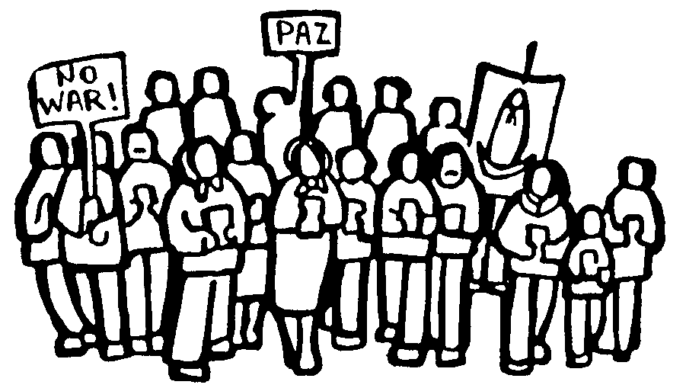
When they fail to divide groups, riot police are sent in lines to break up and disperse crowds, by hitting out with batons.
Mounted (horseback) police are also used in the same way. It's important to understand that once given the order for a baton charge the police won't distinguish between violent or non-violent protesters. As far as they are concerned, if you are not a troublemaker you would have left the area a long time ago. Police in Britain are issued with metal retractable batons, which cause nasty head wounds but minimise the risk of brain damage or death.
CS gas is issued, but not often used - guidance refers to life threatening situations. Pepper spray is used, not generally in crowds, but mostly when making arrests by spraying in the face. Water cannons have never been used on the British mainland but are being talked about.
Horses are used to protect buildings, seal off streets, and to push back and split groups of people. The only safe response is to move out of the path of the horses calmly but swiftly. Do not sit down in front of them, unless you want to get trampled. Instead, move around the horses and fill up the space behind them as soon as the horses have passed.
Tips for large protests:

- Form affinity groups and have a buddy with you.
- Stay alert and keep moving around, as a group and individually.
- Fill gaps and face outwards so you can see what's going on.
- Link arms if possible – this forms protective barriers and gives moral support.
Dogs may also be used, especially to protect buildings, patrol rural areas and for sniffing for drugs.
Snatch Squads are small groups of cops (usually six, in a triangular formation) who are sent into the crowd to snatch and arrest individuals. These might be people that the cops think are “ring leaders”, or just people they don't like the look of. They also like to target people with musical instruments, cameras and the like. Watch out for each other and if you see a snatch squad approaching let people around you know about it. You can sometimes spot a senior police officer pointing out people they want arrested. Often a snatch squad is used to incite violence, to create a pretext for attacking the protesters.
Be aware that police officers do not like to be isolated from their colleagues and will often react very violently to this situation.
Intelligence gathering is the police's favourite intimidation tactic. Expect to see lots of intelligence gatherers with video and stills cameras. CCTV cameras will often be installed on roof tops and you will be filmed from helicopters hovering above. One way to protect yourself from this is to wear a wide brimmed hat and sunglasses or fancy dress. Be aware though that the police can arrest you if you refuse to take off “any items worn for disguise”.
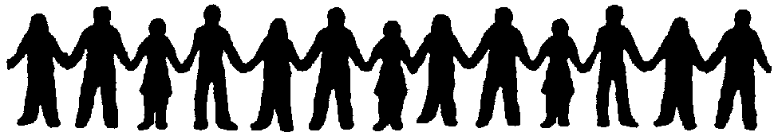
....Dealing with the Police....
You'll undoubtedly get into contact with the police. Make sure you have a bust card with the basic legal information with as well as phone numbers for your legal support group. Write the numbers of legal support and solicitors on your hand or arm when going on an action in case you loose the bustcard. If you get stopped or arrested contact legal support straight away.

- Be calm and assertive. Don't be intimidated. Know your rights.
- Ask to speak to the senior officer present (PCs know nothing anyway).
Don't
Panic!
- Try not to lose your temper or swear (this may be used as an excuse to arrest you).
- Lay off the drink (this may also be used as an excuse to arrest you).
  - Keep a watchful eye out for other police and other protesters.

The police will ask you all sorts of questions which you're not obliged to answer. They are out to gather information. Don't give it to them, for your sake and that of your fellow protesters. You don't even have to give your name and address when you are randomly stopped or searched. The only time you do have to give your name and address is when the cops reasonably suspect you of committing or witnessing an offence or when they detain/arrest your.
“No comment”!
Security resources
General Security
- www.activistsecurity.org - security for activists site - still being built, but contains a comprehensive briefing on security issues.
- www.mcspotlight.org/case/trial/story.html - story of the McLibel case, including information about infiltration.
- ww.freebeagles.org/articles/mobile_phones.html - mobile phones.
- www.angelfire.com/pe2/peaceproject/activ.html - article about covert activities against activist groups - including lots of useful web links.
- www.theregister.co.uk/2001/09/06/eu_releases_echelon_spying_report/ - article on EU report on Echelon (plus link to EU report)
- www.no2id.net/ - Campaign against Identity Cards in the UK.
- http://indymedia.org.uk/en/2004/10/300000.html - account of how police intercepted a covert GM action.
- www.eco-action.org/rr/ch13.html - Road Raging Campaign Security.
Computer Stuff
- www.pgpi.org/ - get PGP for Windows (for Linux, use GPG and look in your distribution disks!)
- www.shac.net/pgp - how to use PGP for Windows.
- secdocs.net/manual/lp-sec/ - APC's particpating in safety computer briefings.
- www.anon.inf.tu-dresden.de/ - Free Anonymous Proxy (anonymous web browsing).
- http://www.theregister.co.uk/security/security_report_windows_vs_linux/ - report comparing security of Windows and Linux.
- www.evel.nl/spinwatch/TRFrontpage.htm - Eye opening account of big business infiltrating and incapacitating protest groups
Recommended Reading
Battling Big Business - Countering greenwash, infiltration and other forms of corporate bullying, Eveline Lubbers, Green Books, 2002, ISBN 190399814X
http://news.com.com/2100-1029-6140191.html - bugging switched off phones.
Action support

Run by activists for activists - make use of them!

UK Action Medics
Train medics for your affinity groups to provide first aid on actions www.actionmedics.org.uk

Activist-Trauma Group
Workshops/info on post-traumatic stress, how to help yourself / your friends, individual support and group debriefings.www.activist-trauma.net

Action Trainers
Workshops and guides on direct action and consensus, forming affinity groups, action techniques, exploring non-violence, security, media etc.
www.seedsforchange.org.uk
www.tridentploughshares.org
www.turning-the-tide.org
www.activistsecurity.org
www.eco-action.org/blinc
www.uhc-collective.org.uk/knowledge/toolbox/toolbox.htm
General NVDA Guides / Activist resources
www.eco-action.org/rr/ - Anti roads protest guide
www.geneticsaction.org.uk/resources/delia.pdf – Interesting blockading guide
www.actupny.org/documents/CDdocuments/CDindex.html - New York site with loads of resources
www.starhawk.org/activism/activism.html
www.earthfirst.org.uk/manchester/porder.htm – public order guide
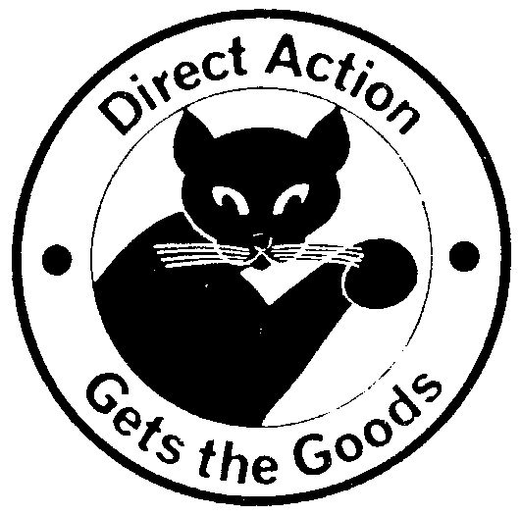
www.peacenews.info/tools – includes dealing with fences and organising mass actions

Info on legal rights
www.activistslegalproject.org.uk
www.yourrights.org.uk/
www.freebeagles.org

